**PERFORMANCE ANALYSIS OF LOAD BALANCING ALGORITHMS IN CLOUD HETEROGENOUS ENVIRONMENT**



***A Project Report submitted in partial fulfilment of the requirements for the award of the degree of***

**Bachelor of Technology**

**in**

**Computer Science and Engineering**

**by**

**Aayushi Rai (171510003)**

**Deepika Rao (171510019)**

**Payash Agarwal (171510035)**

**Pranjul Singhal (171510040)**

**Rashi Bansal (171510044)**

Under the Guidance of

Mr. Vivek Sharma, Assistant Professor

Department of Computer Engineering & Applications

**Institute of Engineering & Technology**

**GLA University**

**Mathura- 281406, INDIA**

**May, 2021**



## Department of Computer Engineering and Applications GLA University, Mathura

**17 km. Stone NH#2, Mathura-Delhi Road, P.O.– Chaumuhan, Mathura – 281406**

# Declaration

We hereby declare that the work which is being presented in the B.Tech. Project **“Performance Analysis of Load Balancing Algorithms in Cloud Heterogenous Environment”**, in partial fulfilment of the requirements for the award ofthe ***Bachelor of Technology*** in Computer Science and Engineering and submitted to the Department of Computer Engineering and Applications of GLA University, Mathura, is an authentic record of my own work carried under the supervision of **Mr. Vivek Sharma, Assistant Professor, GLA University, Mathura.**

The contents of this project report, in full or in parts, have not been submitted to any other Institute or University for the award of any degree.

**1. Aayushi Rai (171510003)**

**2. Deepika Rao (171510019)**

**3. Payash Agarwal (171510035)**

**4. Pranjul Singhal (171510040)**

**5. Rashi Bansal (171510044)**

**Department of Computer Engineering and Applications GLA University, Mathura**

**17 km. Stone NH#2, Mathura-Delhi Road, P.O.– Chaumuhan, Mathura – 281406**

# CERTIFICATE

This is to certify that the project entitled **“Performance Analysis of Load Balancing using Cloud Analyst”** carried out in Mini Project is a bonafide work done by **Aayushi Rai (171510003), Deepika Rao (171510019), Payash Agarwal (171510035), Pranjul Singhal (171510040) and Rashi Bansal (171510044)** is submitted in partial fulfillment of the requirements for the award of the degree Bachelor of Technology (Computer Science & Engineering).

**Signature of Supervisor:**

**Name of Supervisor: Mr. Vivek Sharma Date:**

**ACKNOWLEDGEMENT**

It gives us a great sense of pleasure to present the report of the B. Tech Mini Project undertaken during B. Tech. Fourth Year. This project in itself is an acknowledgement to the inspiration, drive and technical assistance contributed to it by many individuals. This project would never have seen the light of the day without the help and guidance that we have received.

Our heartiest thanks to **Dr. (Prof). Anand Singh Jalal,** Head of Dept., Department of CEA for providing us with an encouraging platform to develop this project, which thus helped us in shaping our abilities towards a constructive goal.

We owe special debt of gratitude to **Mr. Saurabh Anand,** Program Coordinator, Department of CEA, for his constant support and guidance throughout the course of our work. His sincerity, thoroughness and perseverance have been a constant source of inspiration for us. He has showered us with all his extensively experienced ideas and insightful comments at virtually all stages of the project & has also taught us about the latest industry-oriented technologies.

We owe special debt of gratitude to **Mr. Vivek Sharma,** Assistant Professor Department of CEA, for his constant support and guidance throughout the course of our work. His sincerity, thoroughness and perseverance have been a constant source of inspiration for us. He has showered us with all his extensively experienced ideas and insightful comments at virtually all stages of the project & has also taught us about the latest industry-oriented technologies.

We also do not like to miss the opportunity to acknowledge the contribution of all faculty members of the department for their kind guidance and cooperation during the development of our project. Last but not the least, we acknowledge our friends for their contribution in the completion of the project.

**1. Aayushi Rai (171510003)**

**2. Deepika Rao (171510019)**

**3. Payash Agarwal (171510035)**

**4. Pranjul Singhal (171510040)**

**5. Rashi Bansal (171510044)**

# ABSTRACT

In today’s environment the challenging task within cloud computing is to distribute workload among all arriving requests and also balancing those requests. To improve entire system performance, a broker policy has been taken into addition which distributes workload equally with different datacenters in computing environment. A different VM load balancing algorithm will be compared along with different data center broker policies. A cloud analyst simulator, simulate these approaches and final results will be evaluated on several parameters. It covers all the feasible simulations and results will specify the finest possible combinations.

# Table of Contents

Declaration ii

Certificate iii

Acknowledgement iv

Abstract v

**CHAPTER 1 Introduction 1**

1.1 Overview and Motivation 1

1.2 Objective 1

**CHAPTER 2 Software Requirement Analysis 2**

2.1 Requirement Analysis

2.2 Modules and Functionalities

**CHAPTER 3 Software Design 5**

**CHAPTER 4 Installation and Setup 6**

**CHAPTER 5 Implementation and User Interface 8**

**CHAPTER 6 Results and Discussion 13**

**CHAPTER 7 Conclusion 46**

**CHAPTER 8 References 47**

**Chapter 1**

**INTRODUCTION**



Cloud computing is a computing system where communication takes place between thousands of computer systems to fulfill the user’s needs, where user feels that as if he/she using a particular large resource. Cloud computing gives a larger number of computing assets, applications, storage for huge quantity of data and many more. The idea behind Cloud Computing is to give secured, speedy and suitable data storage and figuring organizations.

Cloud computing mainly focuses to give maximum numbers of shared resources and support for user requests in actual time. The cloud services are of three classes: Infrastructure as-a-Service (IaaS), Platform-as-a-Service (PaaS) and Software- as-a-Service (SaaS).The key disadvantage is its redundant power utilization, enormous quantity of energy loss and higher infrastructure cost.

**1.1 OVERVIEW AND MOTIVATION**

The pervasiveness and power of cloud computing alleviates some of the problem’s application administrators face in their existing hardware and software environments. However, the rapid increase in scale, dynamicity, and diversity of cloud resources necessitates having expert knowledge about the way resources are scheduled. The project gives an insight on key resources types of cloud, its resource orchestration along with the analysis of the performance of algorithms.

**1.2 OBJECTIVE**

To perform load balancing, various algorithms were proposed. All previous algorithms focused on balancing the load in datacenters. Balancing the load between datacenters is so effectual that it distributes the workload equally among datacenters which is approved by datacenter brokers and simulates this approach appropriately. The proposed system consists of two stages in load balancing system the first policy is Cloud App Service Broker which manages routing from users to datacenters. The three datacenter policies are Closest datacenter, Optimize Response Time, REconfigureP dynamically with load. The second is provided by VM load balancing algorithms. Three common algorithms are Round Robin, Throttled, and ESCE which will be compared with these three policies. A Cloud Analyst simulates these approaches and results will be on different Parameters which are Overall Response Time, Datacenter Processing Time etc. It mainly focuses to get better response time for respective algorithms. The result will specify the finest possible solution. The further part will be discussed on simulated scenario and broker policy.

**Chapter 2**

**SOFTWARE REQUIREMENT ANALYSIS**

**2.1 REQUIREMENT ANALYSIS**

**2.1.1 SOFTWARE COMPONENTS**

* + - Eclipse IDE
    - Cloud Analyst (version 2009)
    - JDK installed in the system
    - Any Operating System

**2.1.2 HARDWARE COMPONENTS**

* + - Personal computers with min 8 GB RAM

## MODULES AND FUNCTIONALITIES

**2.2.1 Round Robin Algorithm**

Round Robin is one of the commonly used algorithms which utilize the control called time cuts. It designates the solicitations in a round manner to the current virtual machine without considering the current load on the machine. The downside of this algorithm is that it takes a great response time which will bring down system performance.

The Algorithm focuses on Time Sharing. In this algorithm, every process gets executed in a cyclic way. A certain time slice is defined in the system which is called time quantum. Each process present in the ready queue is assigned the CPU for that time quantum, if the execution of the process is completed during that time then the process will terminate else the process will go back to the ready queue and waits for the next turn to complete the execution.

## Throttled Algorithm

Throttled algorithm starts by appointing appropriate virtual machine when customers send demand to load balancer. This VM load balancing algorithm confines the quantity of solicitations being prepared in each virtual machine to a throttling edge. The primary part of throttled load balancer is to care for a file table of all virtual machine together with their states delineating occupied and accessible mode. If the customer demands making this limit be surpassed in all accessible virtual machines, load balancer returns - 1 and datacenter lines the demand until a virtual machine is accessible.

## Equally Spread Current Execution Algorithm

Equally Spread Current Execution algorithm adjusts the assignments among accessible VM's in an approach to try and out the quantity of dynamic errands at any given time on each VM. ESCE depends on system workload priorities. By inspecting the size, ESCE arbitrarily distributes workload and will transfer the stack to the available virtual machine which has fewer loads. It searches for the virtual machine which has less no of allocation so that all virtual machine is equally distributed among the Vm’s.

**Chapter 3**

**SOFTWARE DESIGN**

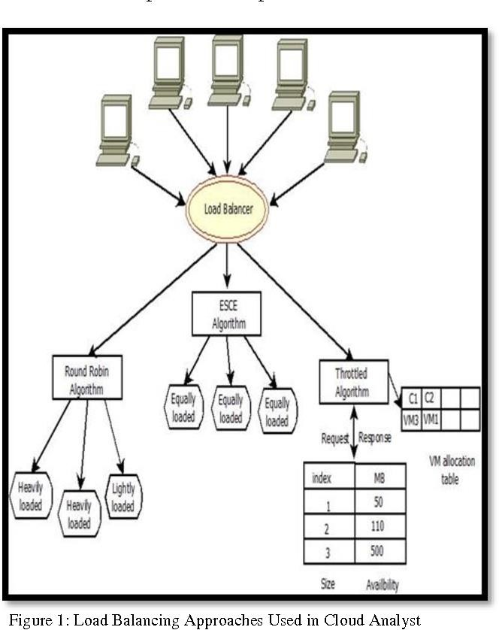

**Fig 1. Load Balancing Approaches Used in Cloud Analyst**

**Chapter 4**

**INSTALLATION AND SETUP**

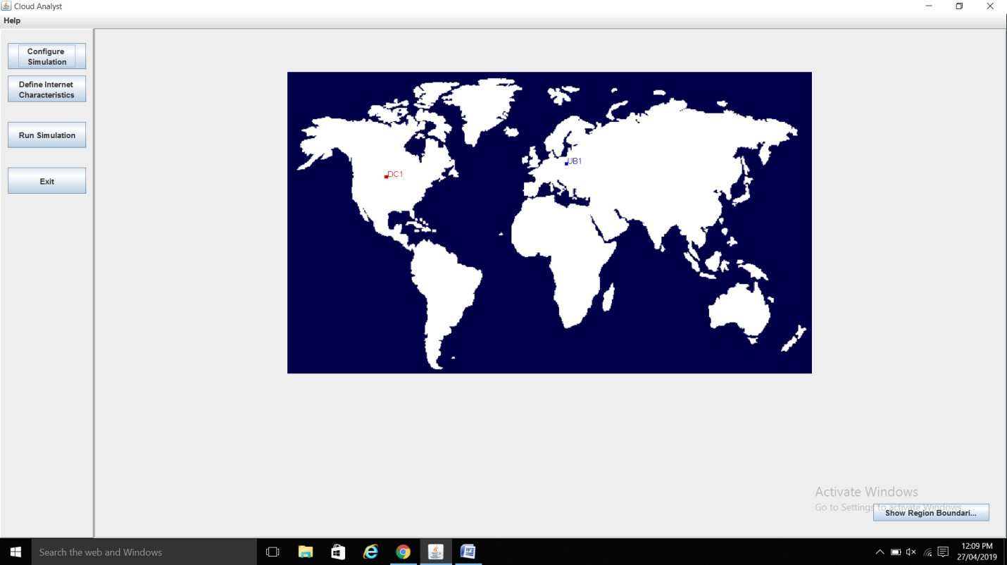

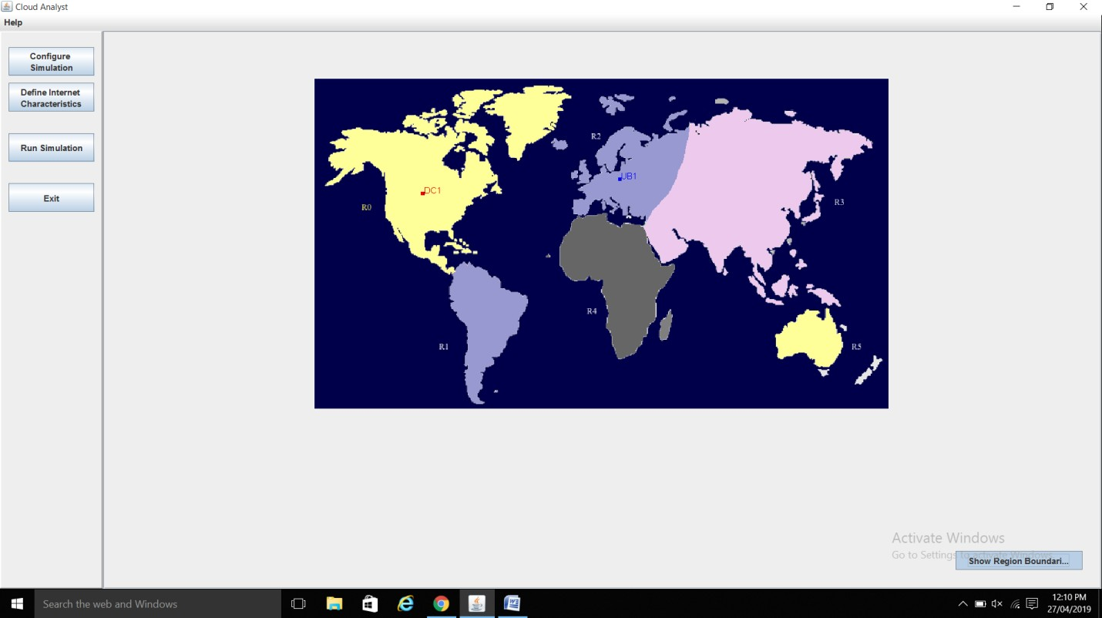

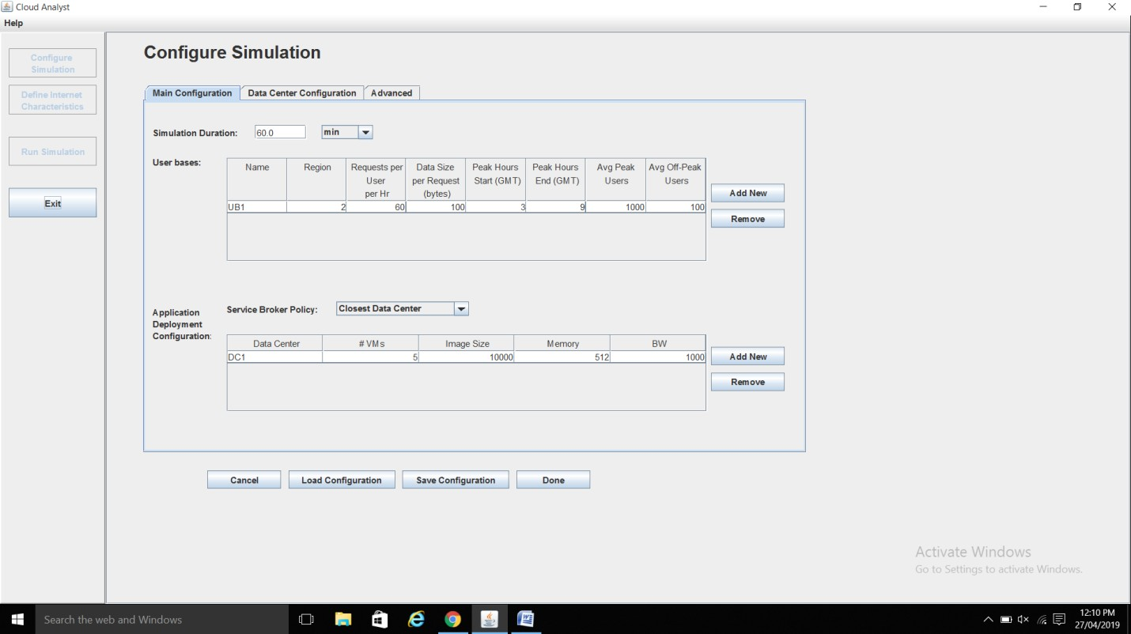

**Chapter 5**

**IMPLEMENTATION AND USER INTERFACE**

In the experimental part a cloud analyst tool has been used to evaluate three algorithms which are Round Robin, Throttled and Equally Spread Current Execution. Simulation is done for six user base with same or different regions for each user. In this simulation four datacenters are taken into addition which is named as DC1, DC2, DC3, and DC4. Cloud Analyst is open resource toolkit which simulates and evaluates various cloud services. Cloud analyst allows modeler to simulate simple experiments with a little variation in parameters in a swift way. Cloud analyst is equipped with a feature called GUI. It is an extended version of CloudSim.

The experimental part consists of detailed information about simulated scenario and datacenter broker policies.

## Simulated Scenario

Figure 2 shows the simulated picture in Cloud Analyst simulator. Datacenter 1 is placed on R0 but has no userbase in R0. There is no datacenter placed in R1 but has one userbase, where R4 has datacenter 2 and one userbase. R2 has no datacenter and no userbase where R5 has only one user base and no datacenter. By this type of scenario it simulate all possible ways for simulation process.



**Fig 5.1. The Cloud Analyst main screen**

**5.2 Configure Simulation Screen**

Configure Simulation screen has three tabs.

**5.2.1 Main Tab-**

The configuration simulation main tab consists of simulation duration, userbases and application deployment configuration. In Simulation Duration, it defines the interval taken by the simulation which is in mins, hours and days. User bases table define a no of users along with their regions, request per user, data size per request etc. In Application deployment configuration, service broker policy provides 3 different policies namely closest datacenter, optimize response time and reconfigure with dynamically with load to be chosen. It also contains the details of the data like storage size, memory, bandwidth and virtual machines owed to each datacenter.



**Fig 5.2. Main Configuration**

**5.2.2 Data Center Tab-**

The configuration simulation data center tab defines a list of datacenters with the information like regions, OS, VMM, Cost per VMM, Storage cost etc. It also provide the details of the physical hardware of the datacenters with the information like Id, Memory, Storage, No of processors etc.



**Fig 5.3. Datacenter Configuration**

**5.2.3 Advanced Tab-**

The advanced tab contains some important parameters that apply to the entire simulation.

1. User Grouping Factor (in User Bases)

2. Request Grouping Factor (in Data Centers)

3. Executable instruction length (in bytes)

4. Load balancing policy:

* Round-robin
* Equally Spread Current Execution Load
* Throttled



**Fig 5.4. Configure Simulation Advanced tab**

**5.3 Internet Characteristics Screen**

The Internet Characteristics screen can be used to set the Internet latency and bandwidth parameters. It presents two matrices for these two categories.



**Fig 5.5. Internet Characteristics screen**

**5.4 Running a Simulation**

Once the above screens have been used to successfully create a simulation configuration, the user has to go back to the main screen and execute the simulation by selecting the “Run Simulation” from the control panel. This will start the simulation and the progress bar at the top of the simulation panel shows the percentage completion of the simulation. The simulation screen will display a simple animation showing which user bases are sending messages to which data centers.



**Fig 5.6. Simulation Panel during run simulation**

**Chapter 6**

**RESULTS AND DISCUSSIONS**

In these three algorithms are compared with different policies. After Performing Simulation, results will show which policy is best for which algorithm and also calculates the average response time by region, overall response time and data center processing time.

## Closest Datacenter Policy

The ClosestP policy simulates all three algorithms RR, Throttled, ESCE. Below Figure illustrates the complete details of user base and datacenter which displays the average response time of all the user bases and datacenters.

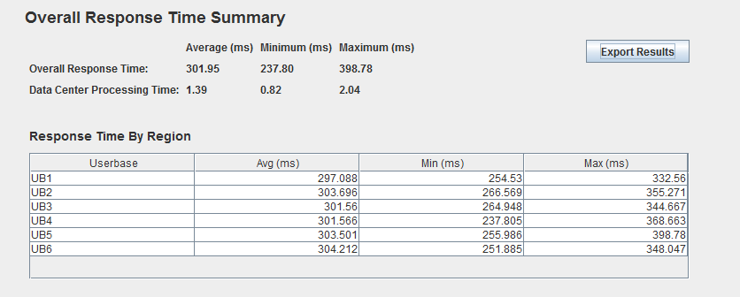

**Fig 6.1. Response Time by Region (Avg ms under closest policy for Throttled)**

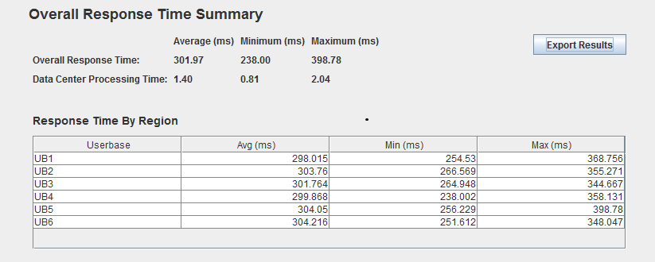

**Fig 6.2. Response Time by Region (Avg ms under closest policy for ESCE)**

## Optimize Response Time Policy (Optp)

The Optp policy simulates all three algorithms RR, Throttled, ESCE. Below Figure illustrates the complete details of user base and datacenter which displays the average response time of all the userbases and datacenters.

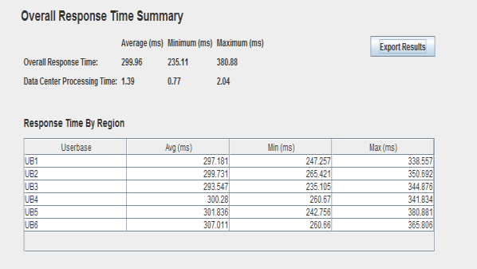

**Fig 6.3. Response Time by Region (Avg ms under optp policy for Round Robin)**

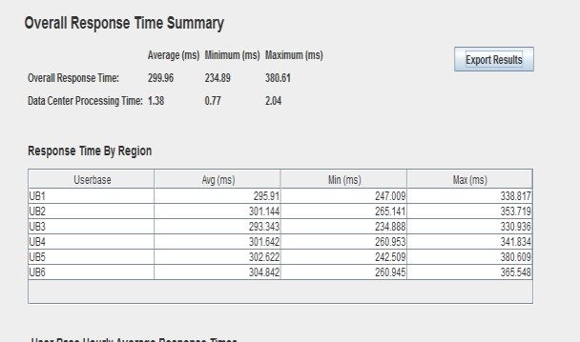

**Fig 6.4. Response Time by Region (Avg ms under optp policy for Throttled)**

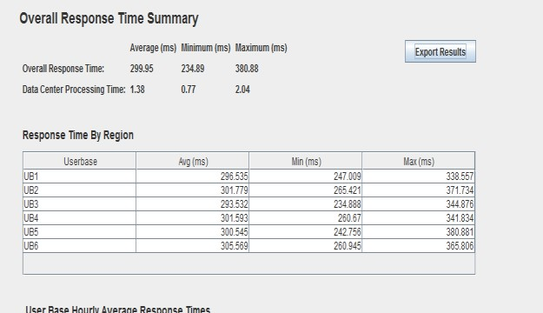

**Fig 6.5. Response Time by Region (Avg ms under optp policy for ESCE)**

## ReconfigureP Policy

The ReconfigP policy simulates all three algorithms RR, Throttled, ESCE. Below Figure illustrates the complete details of user base and datacenter which displays the average response time of all the user bases and datacenters.

**Fig 6.6. Response Time by Region (Avg ms under Reconfigp policy for Round Robin)**

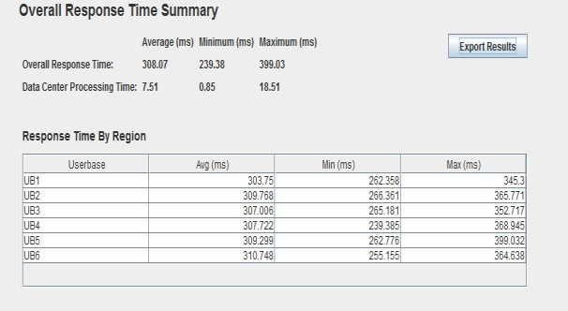

**Fig 6.7. Response Time by Region (Avg ms under Reconfigp policy for Throttled)**

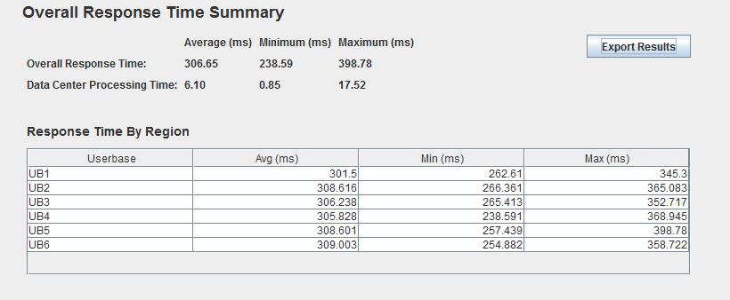

**Fig 6.8. Response Time by Region (Avg ms under Reconfigp policy for ESCE)**

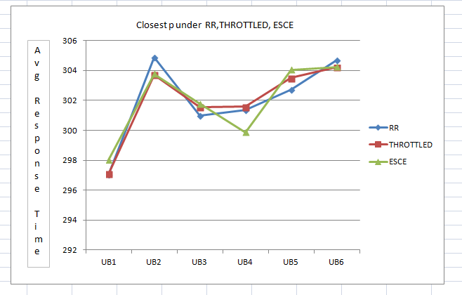

**Fig 6.9. Graph under ClosestP**

The above graph shows the comparison of load balancing algorithms with datacenter broker policy ClosestP. After performing simulation, Throttled algorithm shows minimum average response time under closest p compared to other algorithms.

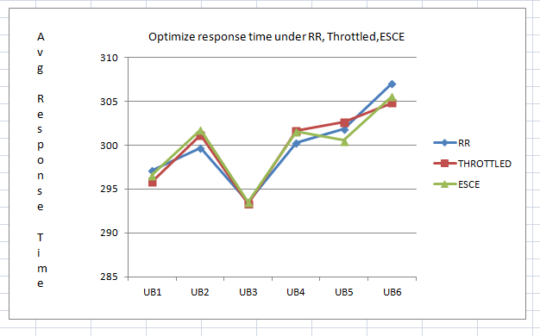

**Fig 6.10. Graph Under OptP**

The graph shows the comparison of load balancing algorithms with datacenter broker policy OptP. After performing simulation, Throttled algorithm shows minimum average response time under OptP when compared with other algorithms.

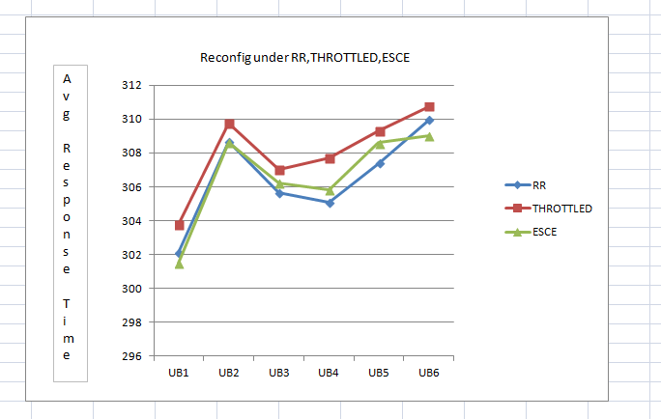

**Fig 6.11. Graph Under ESCE**

The graph shows the comparison of load balancing algorithms with datacenter broker policy ReconfigP. After performing simulation, RR algorithm shows ‘minimum average response time’ under ReconfigP when compared with other algorithms.

# 

# Simulation #1

* **Broker Policy : Closest Data Center**

# Load Balancing Policy : Round Robin

* **Having 20 User Bases**

# Having 5 Data Centers In 5 different Regions

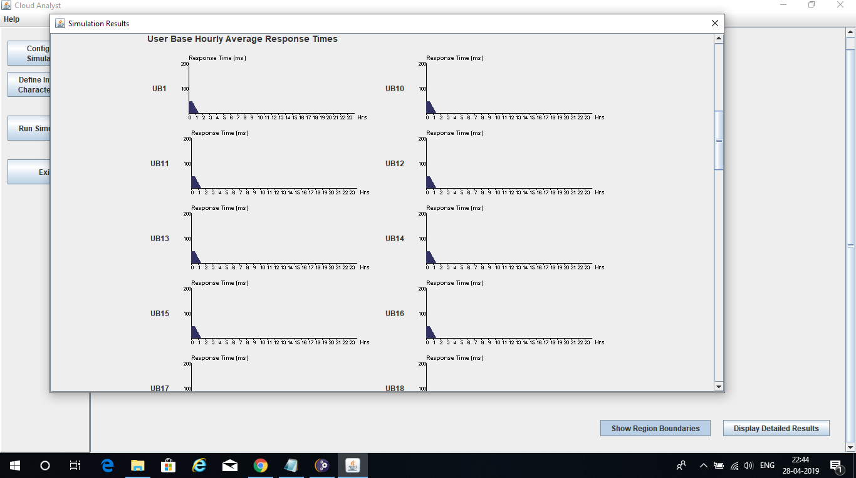

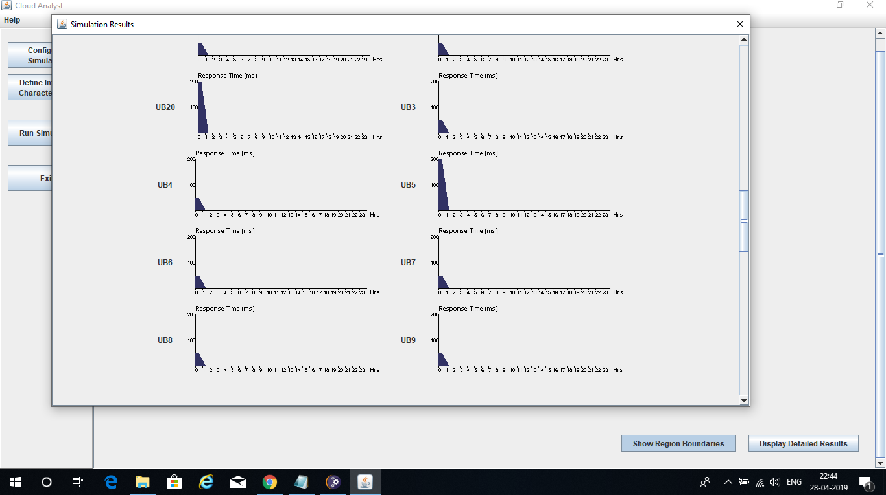

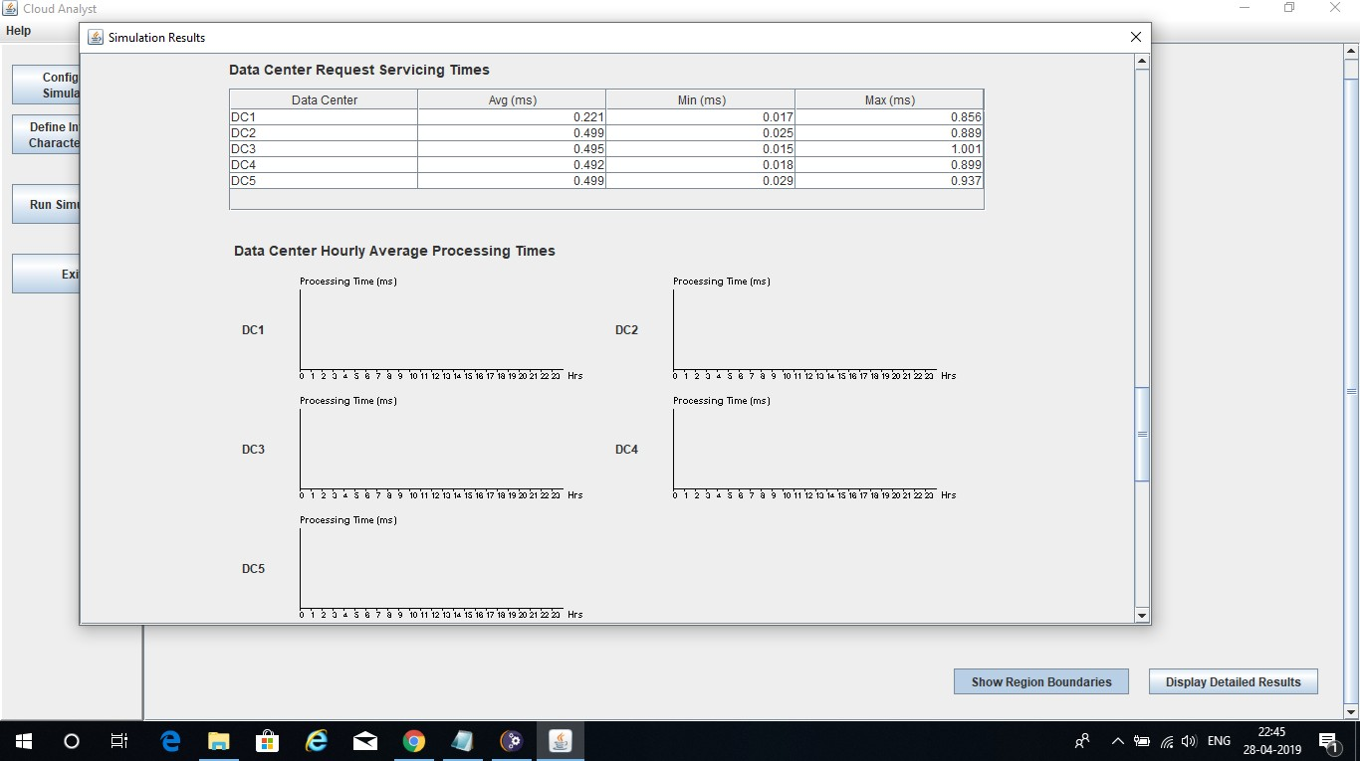

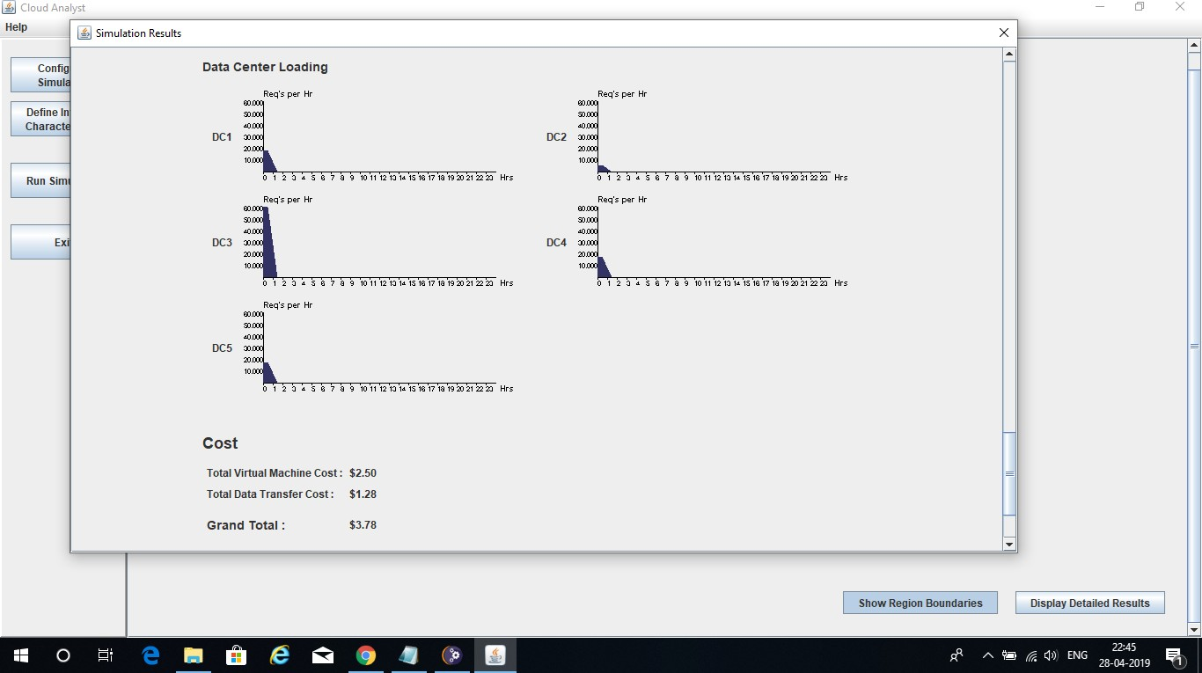

**Simulation #2**

# Broker Policy: Optimize Response Time

* **Load Balancing Policy: Round Robin**

# Having 20 User Bases

* 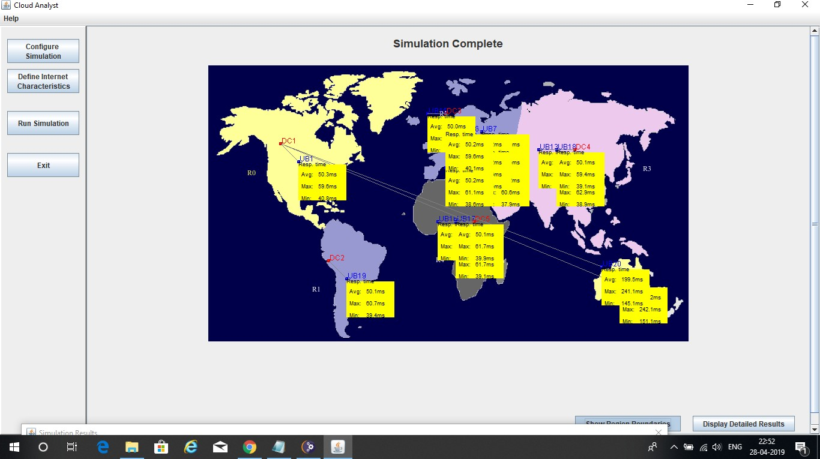**Having 5 Data Centers in 5 different Regions**

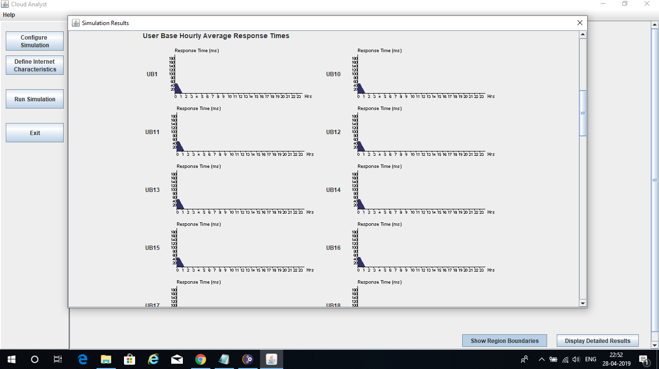

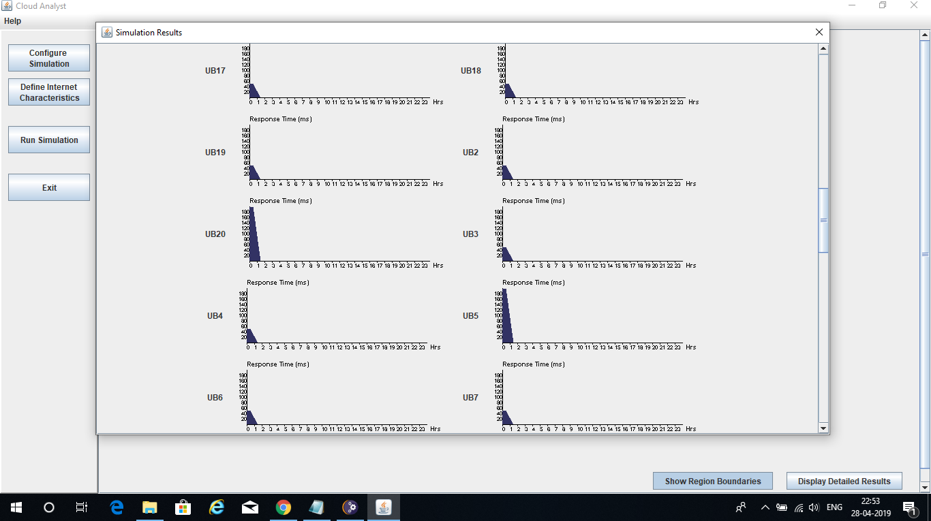

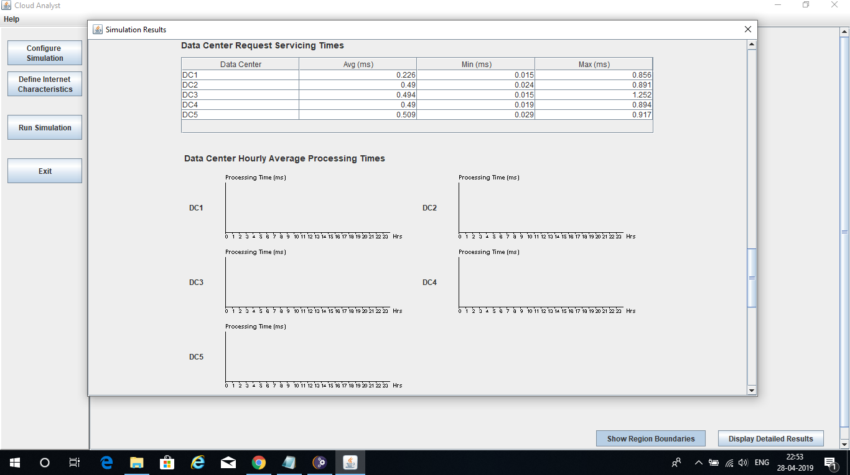

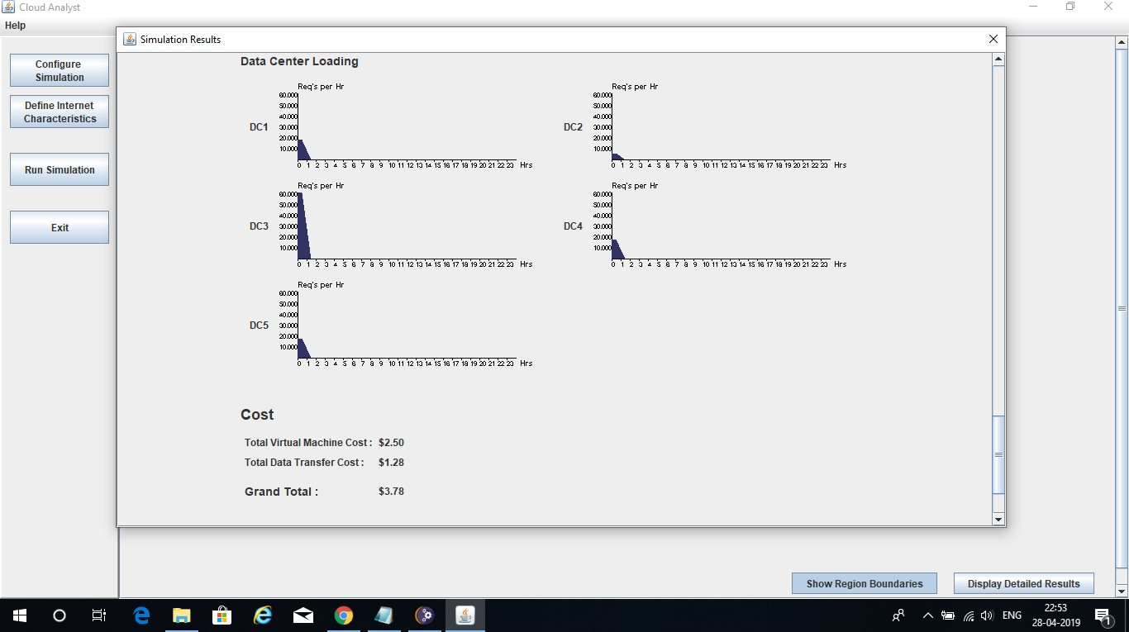

# Simulation #3

* **Broker Policy: Re-configure Dynamically with Load**

# Load Balancing Policy: Round Robin

* **Having 20 User Bases**

# Having 5 Data Centers In 5 different Regions

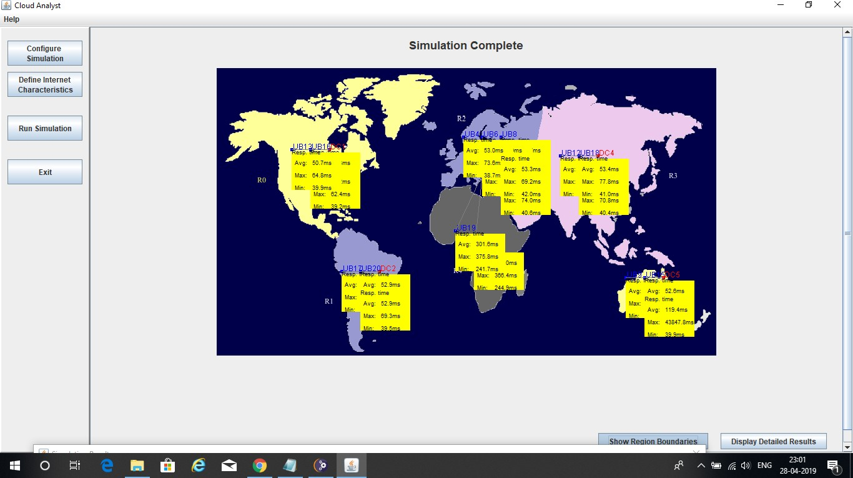

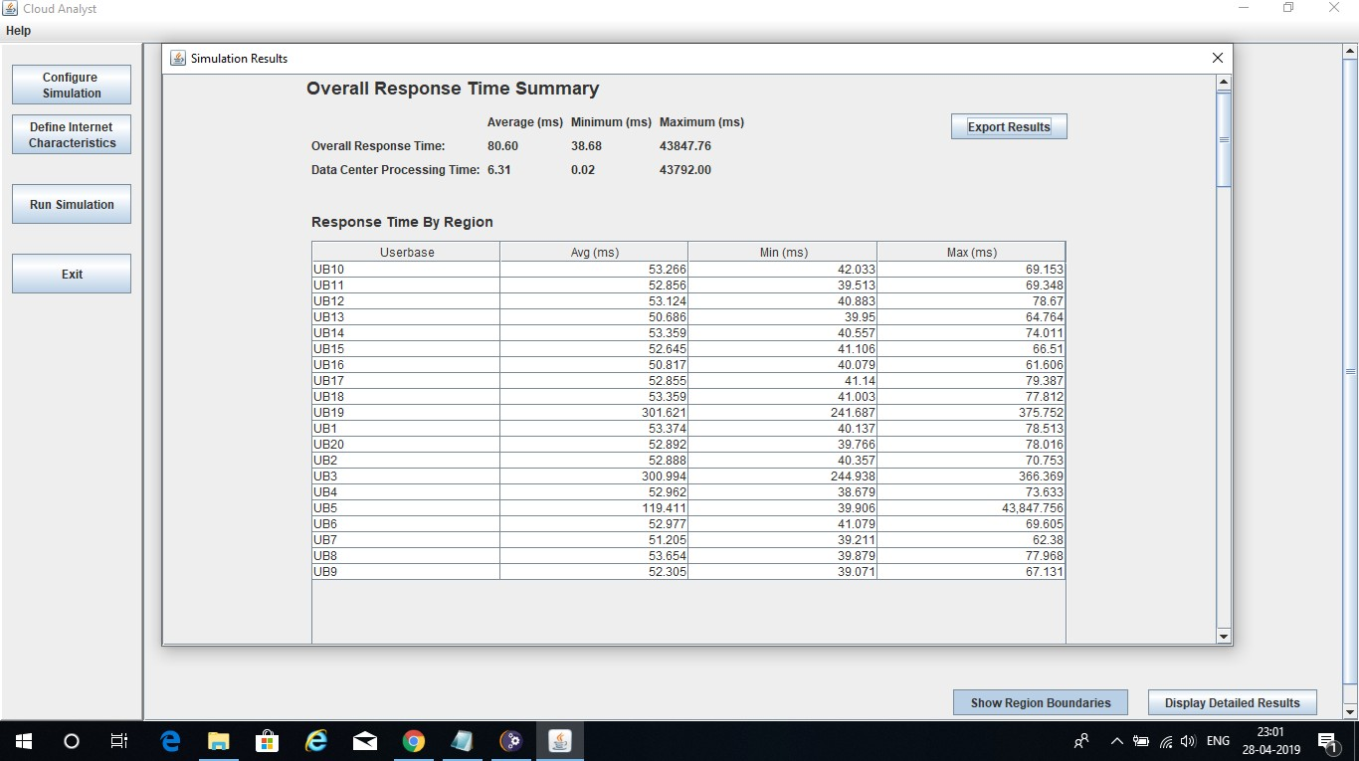

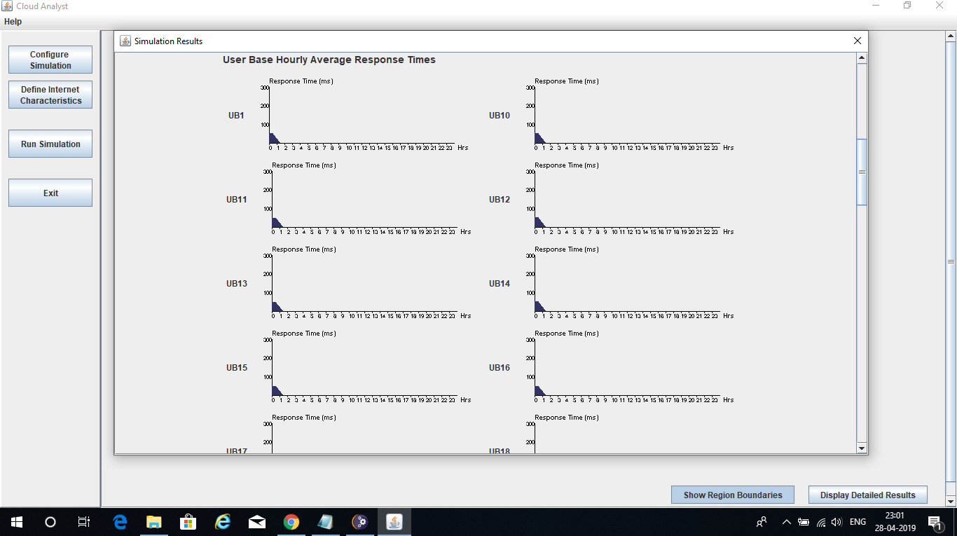

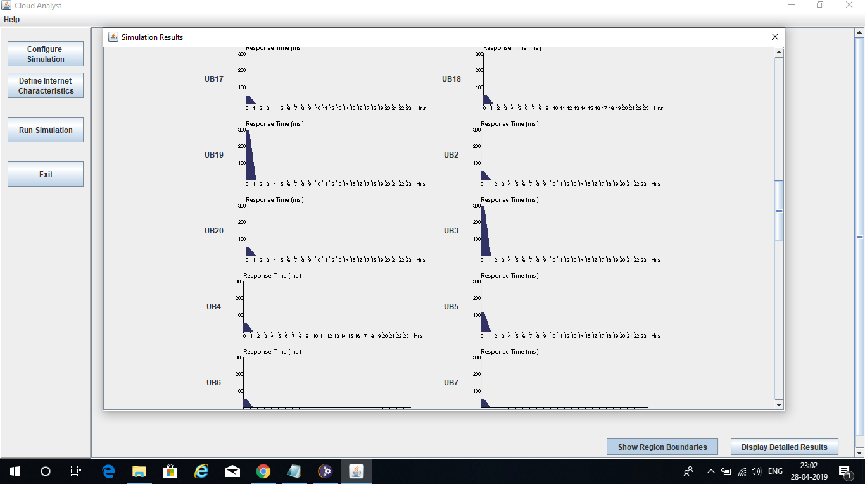

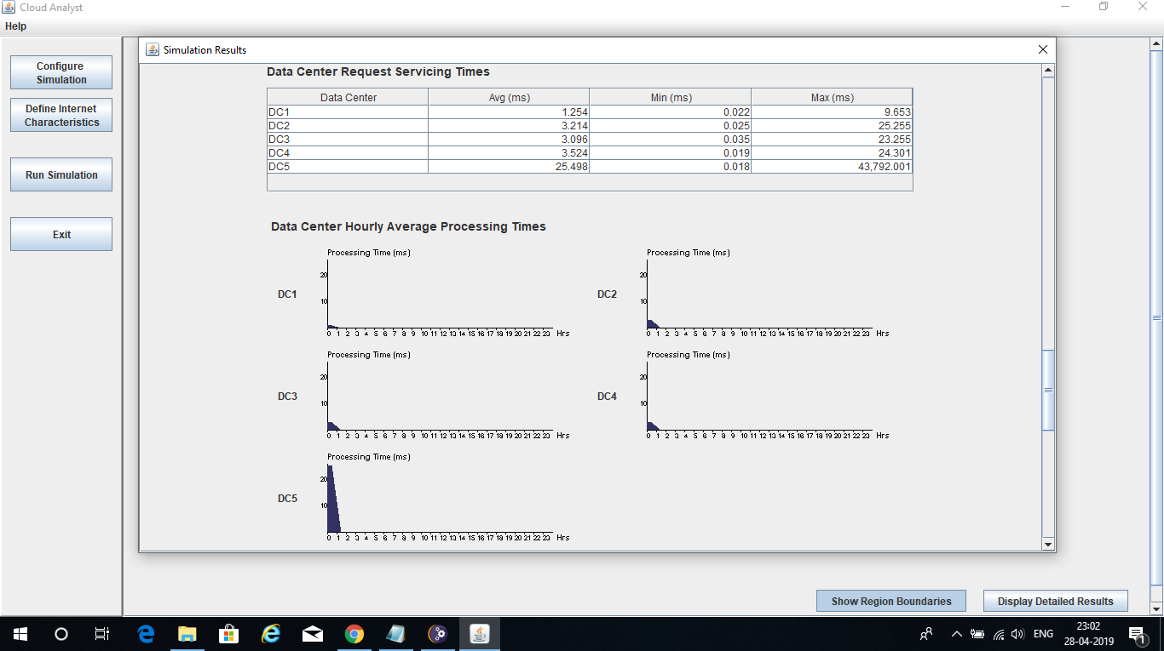

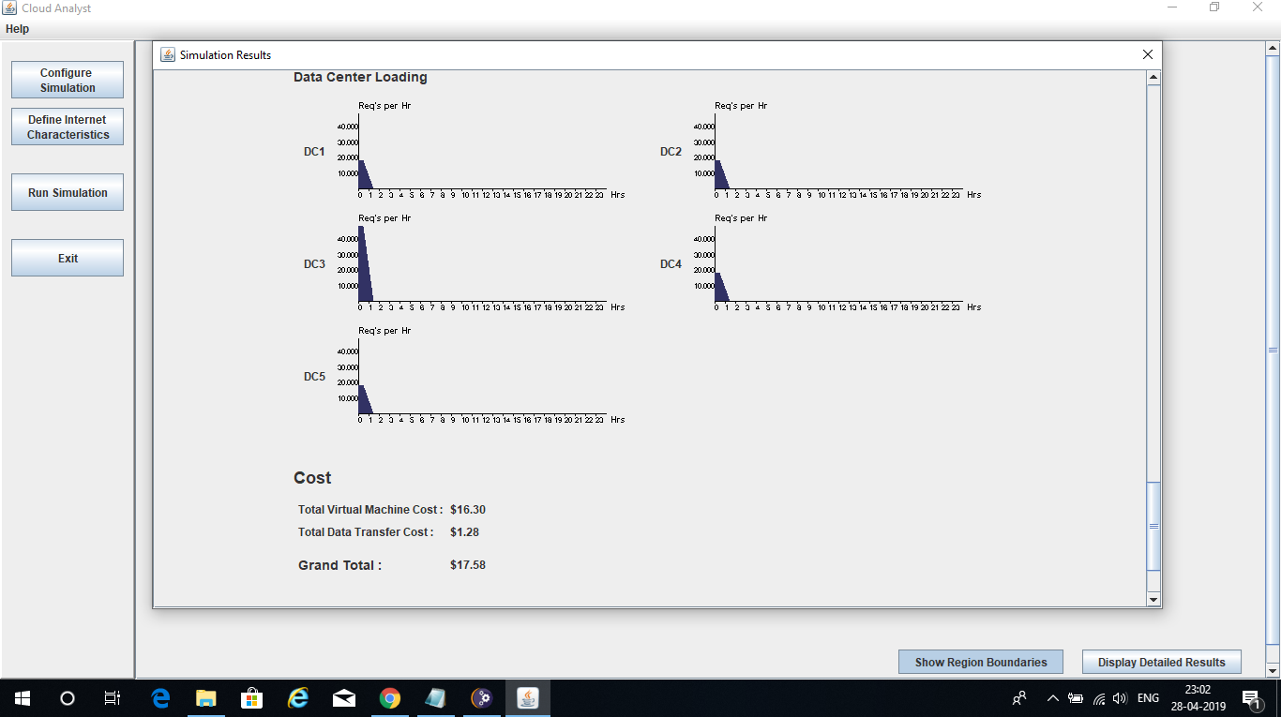

**Simulation #4**

# Broker Policy : Closest Data Center

* **Load Balancing Policy : Throttled**

# Having 20 User Bases

* 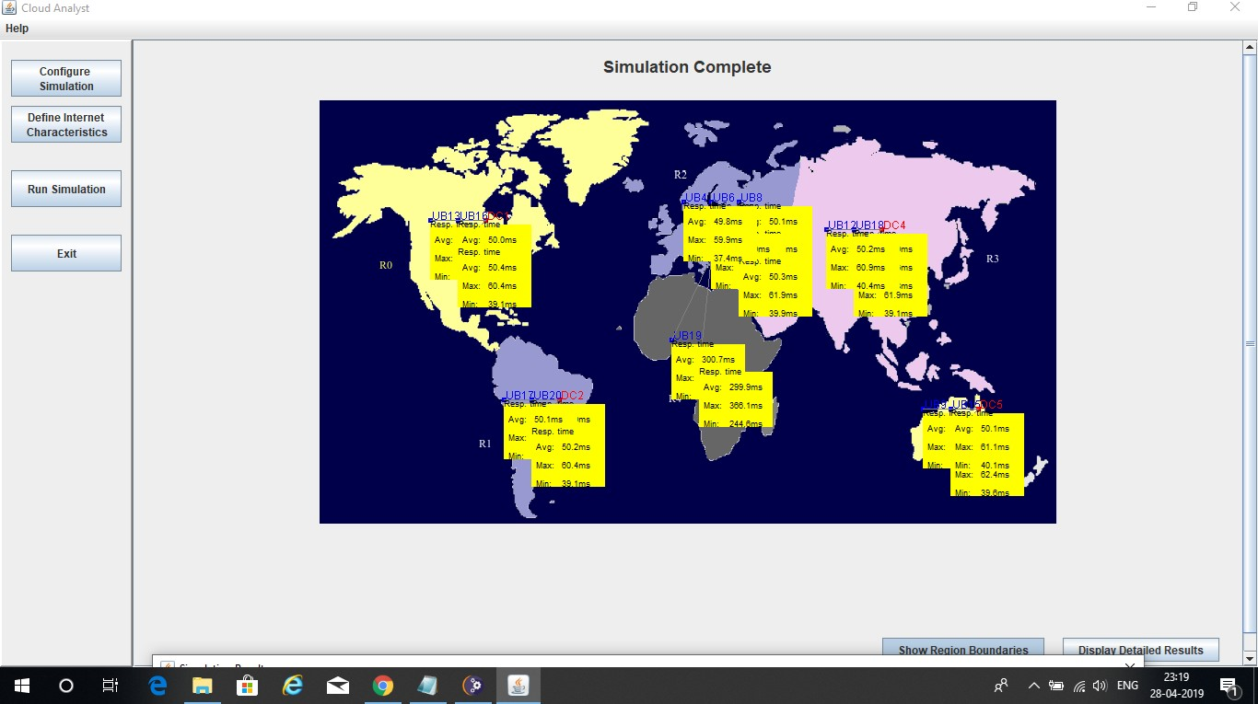**Having 5 Data Centers In 5 different Regions**

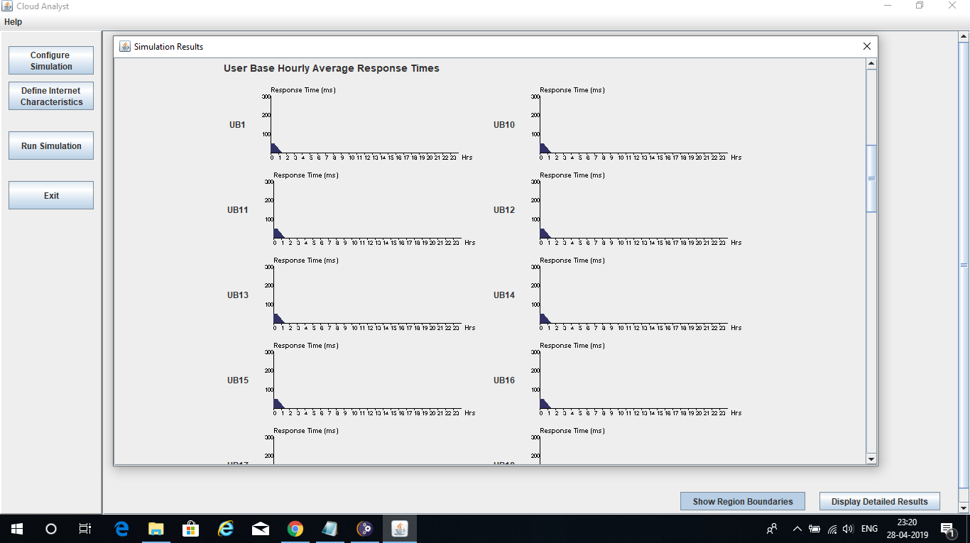

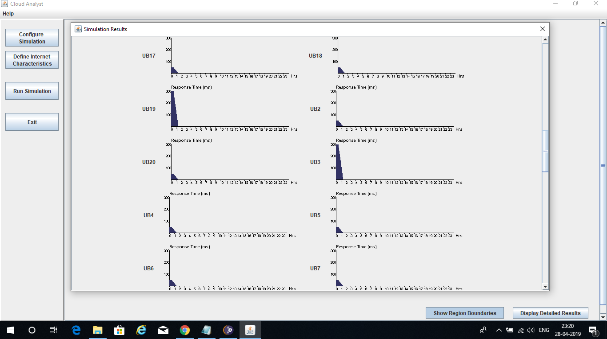

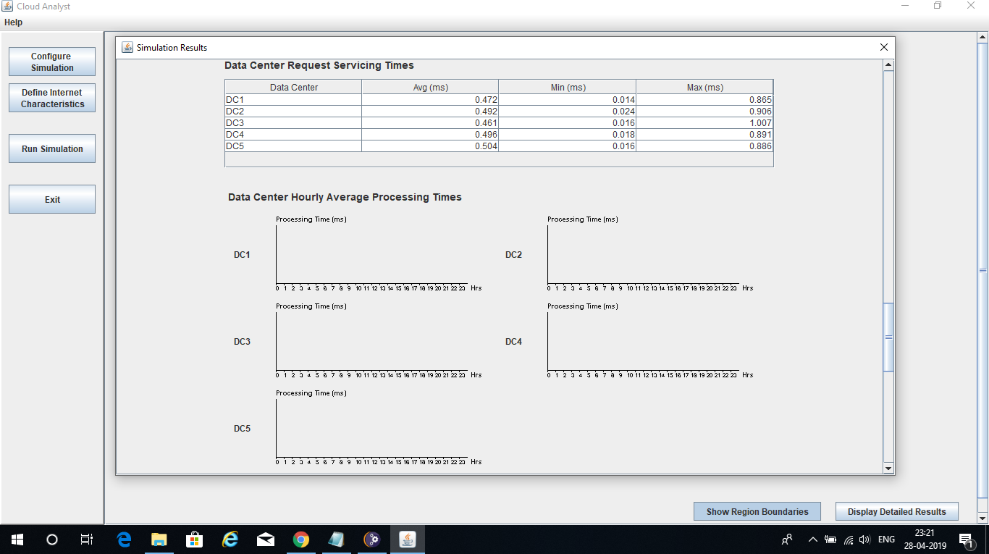

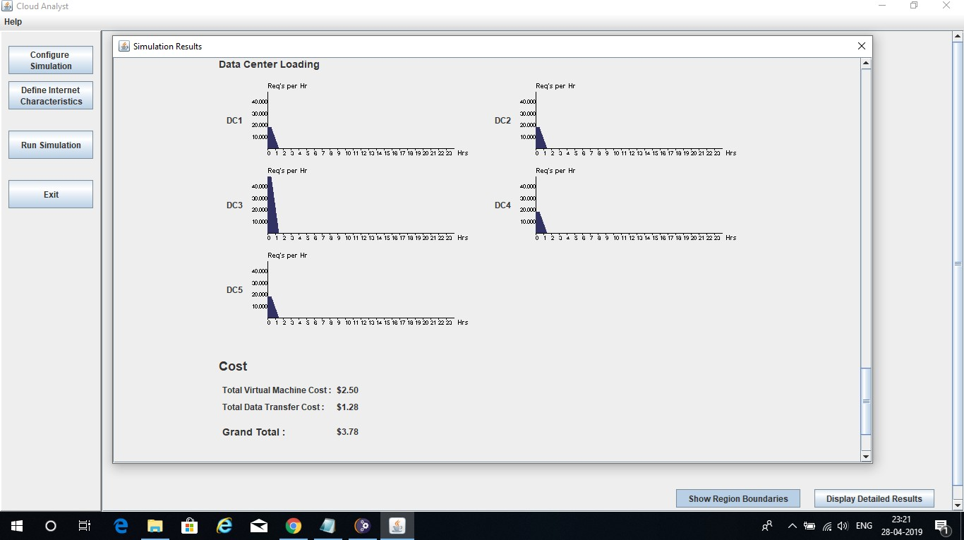

# Simulation #5

* **Broker Policy : Optimize Response Time**

# Load Balancing Policy : Throttled

* **Having 20 User Bases**

# Having 5 Data Centers In 5 different Regions

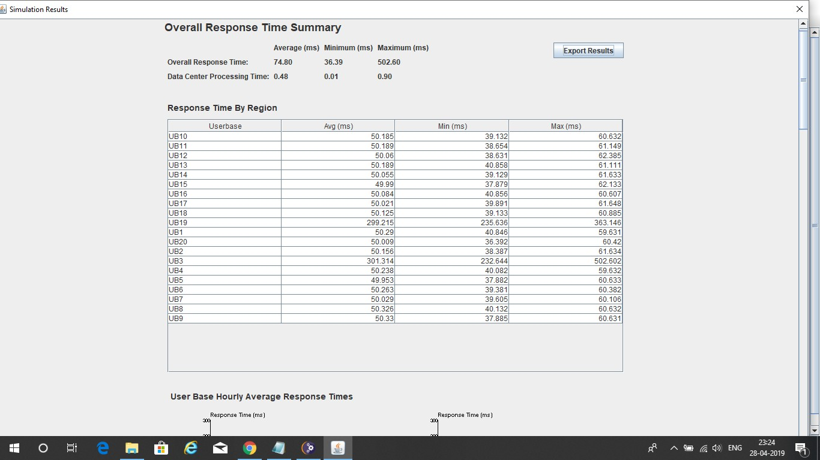

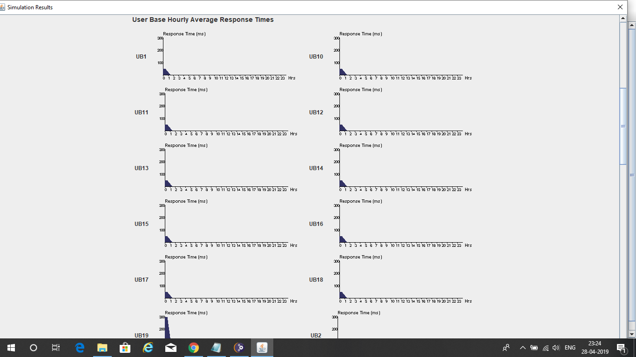

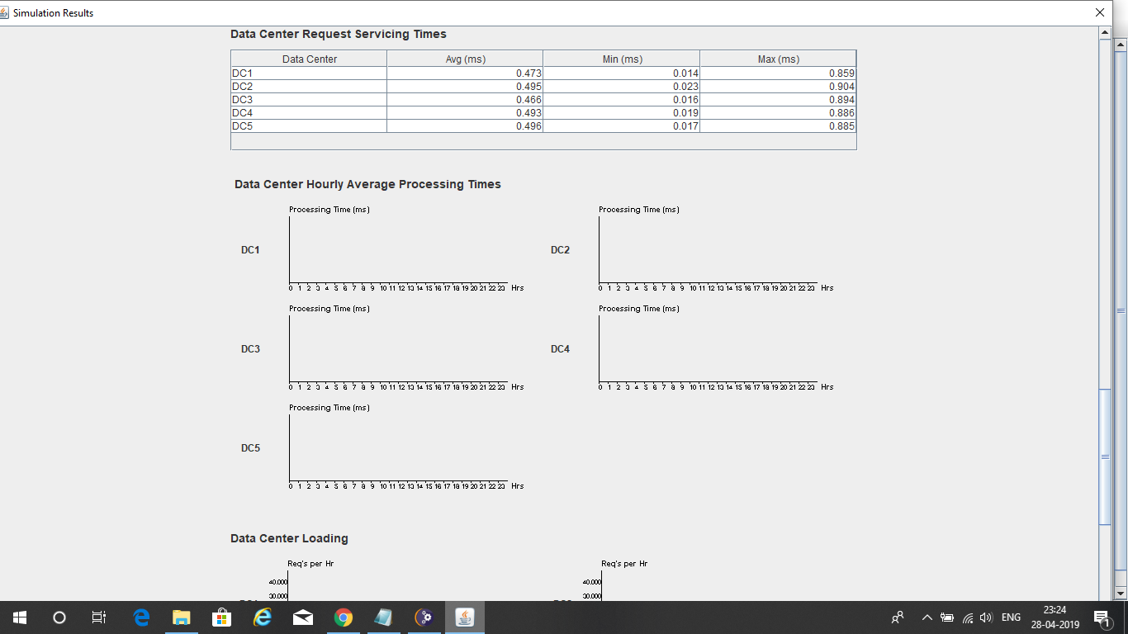

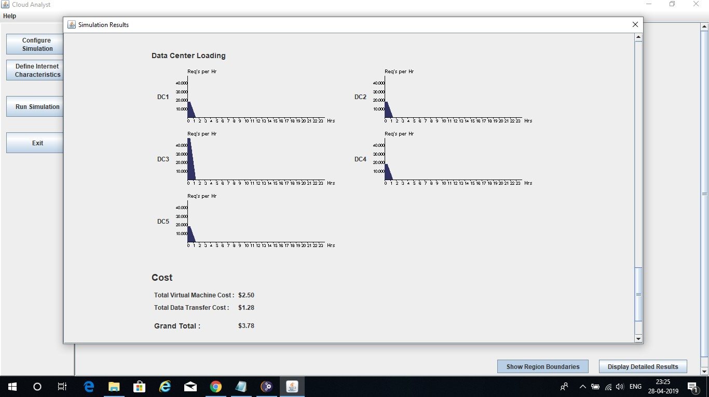

**Simulation #6**

# Broker Policy : Re-configure Dynamically with Load

* **Load Balancing Policy : Throttled**

# Having 20 User Bases

* 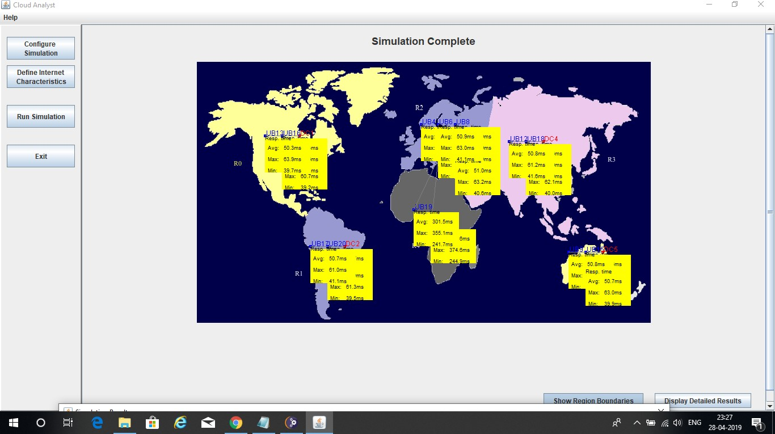**Having 5 Data Centers In 5 different Regions**

# ’

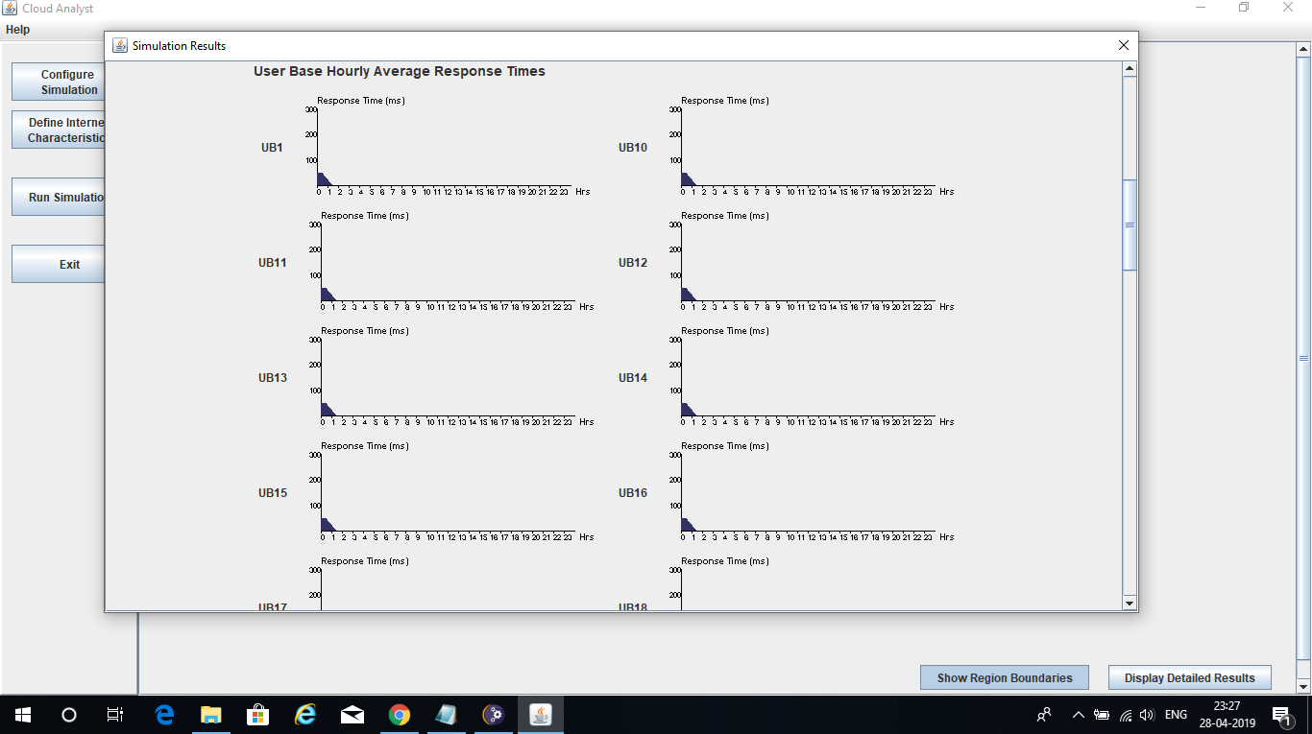

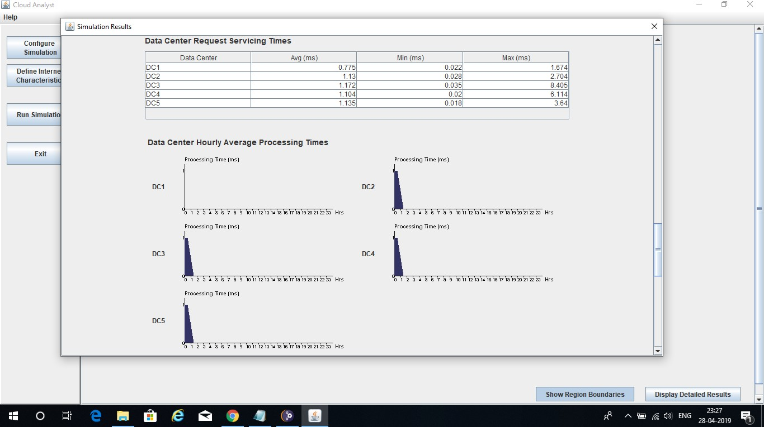

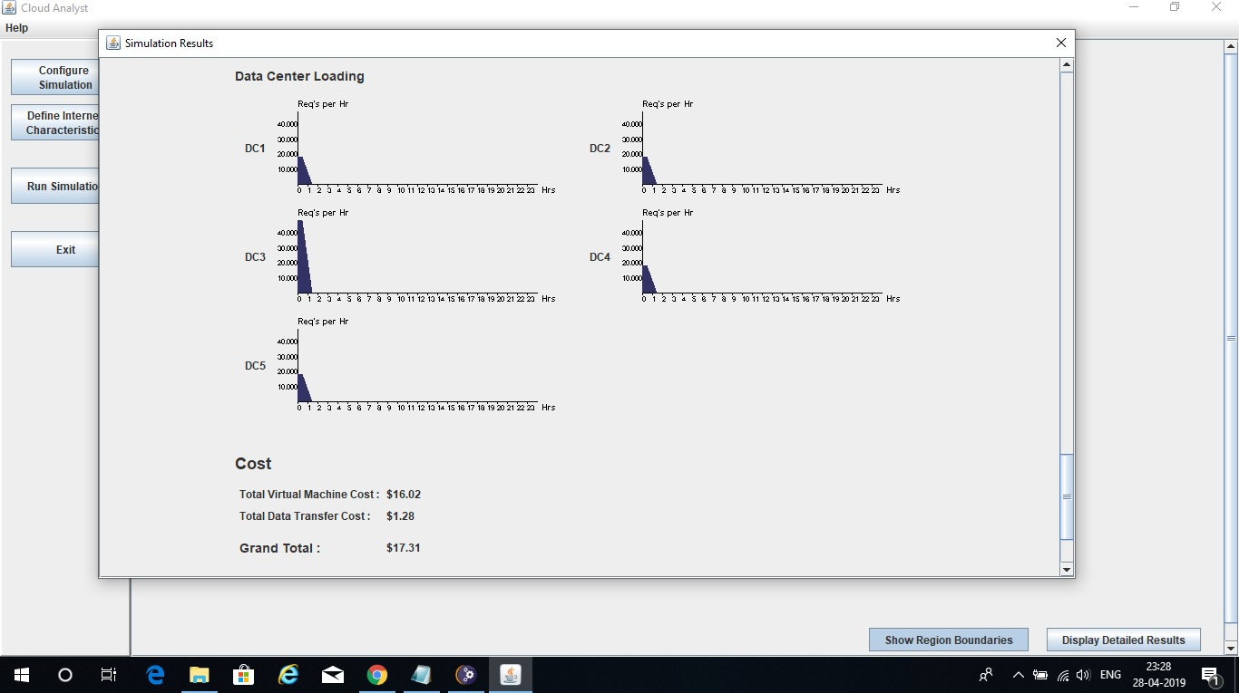

**Simulation #7**

# Broker Policy : Closest Data Center

* **Load Balancing Policy : Equally Spread Current Execution Load**

# Having 20 User Bases

* 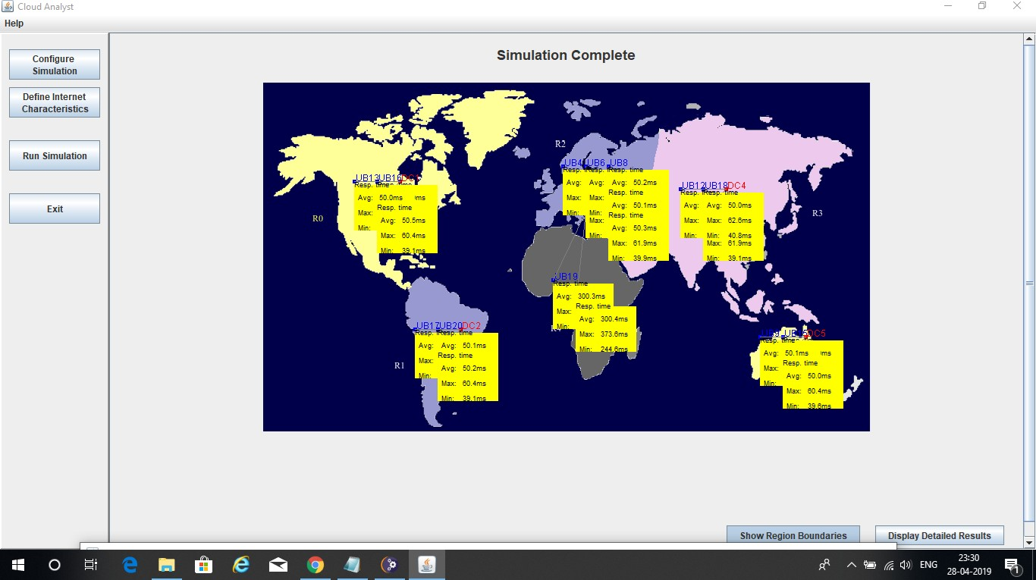**Having 5 Data Centers In 5 different Regions**

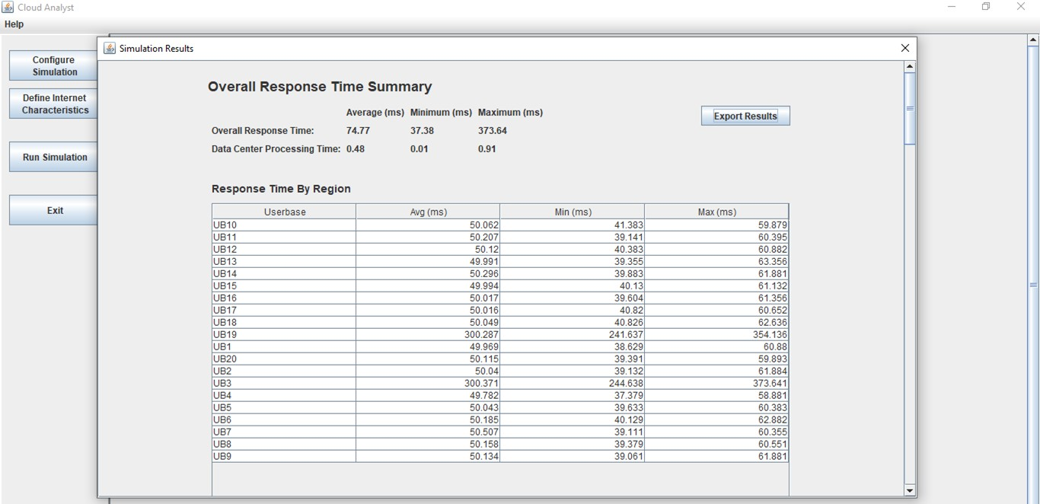

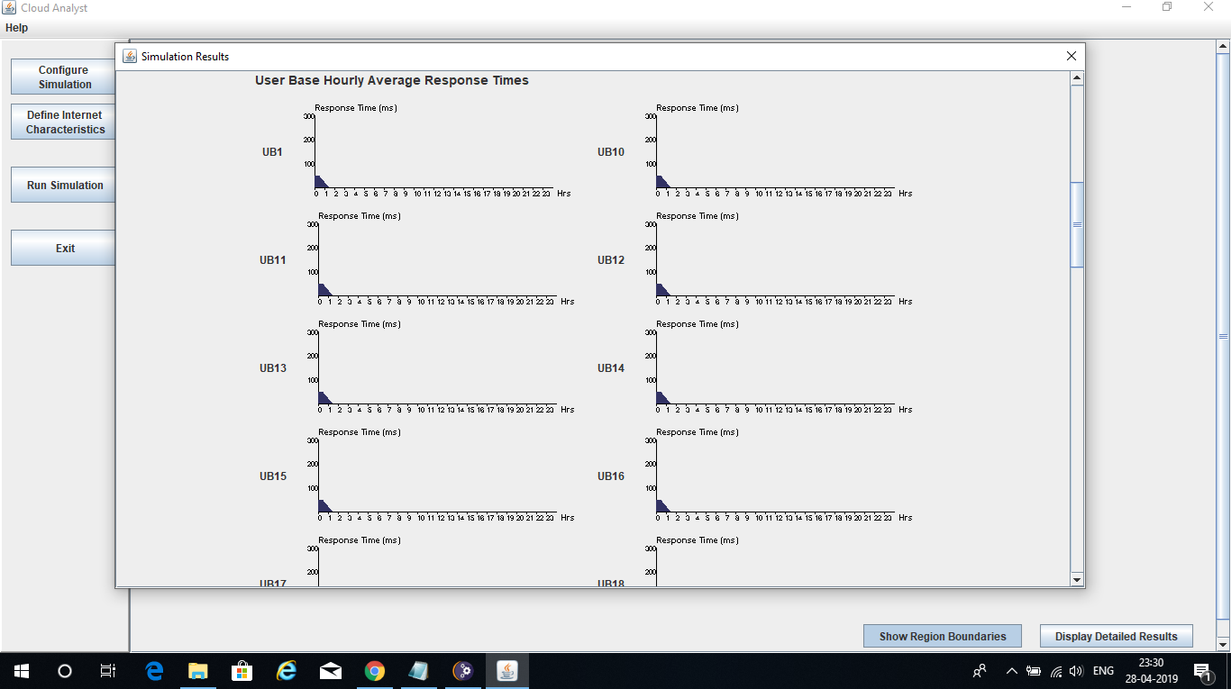

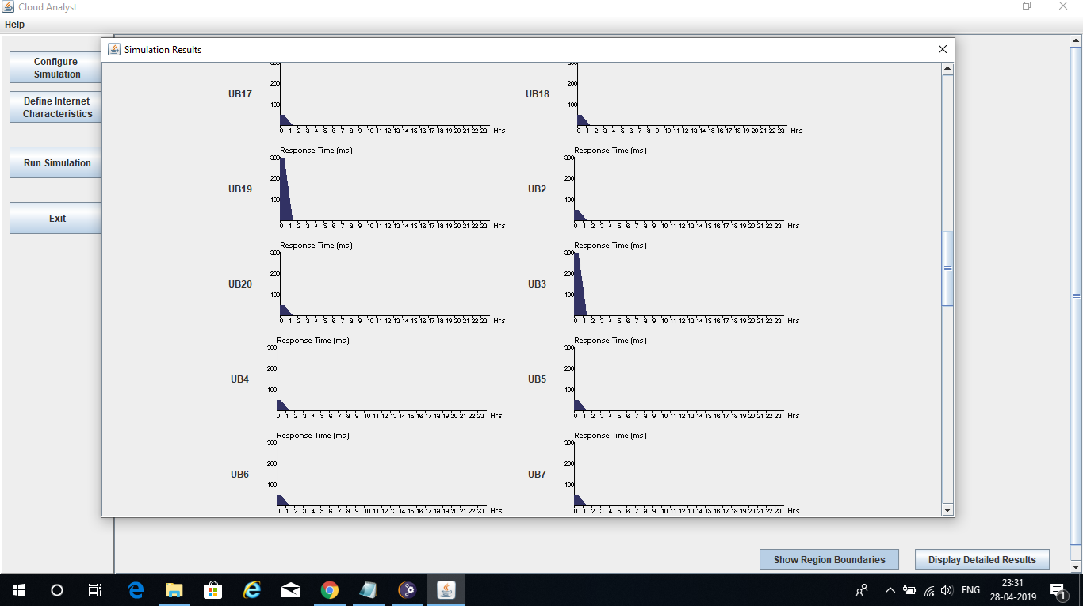

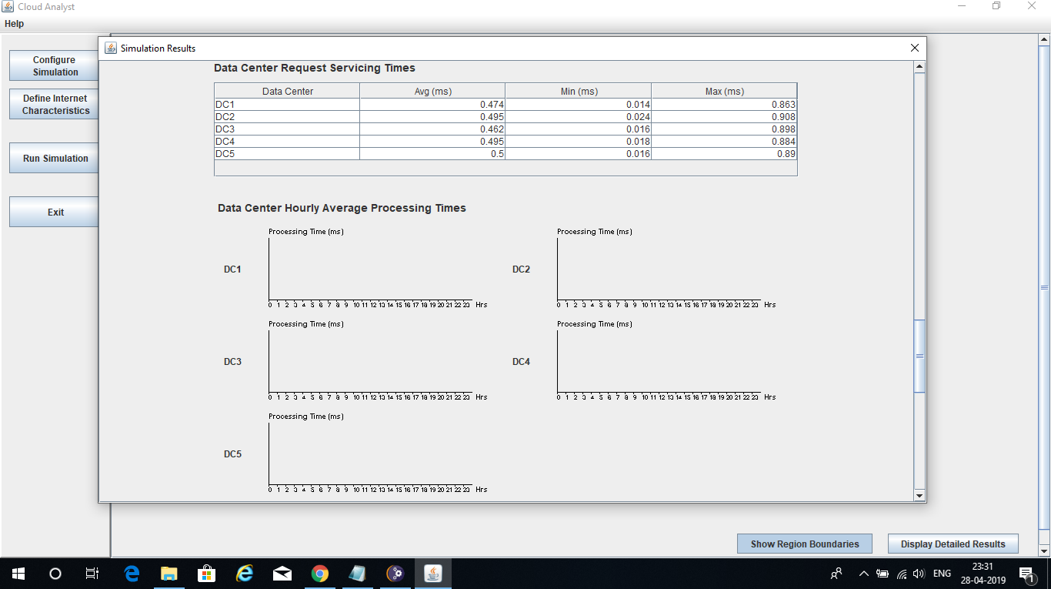

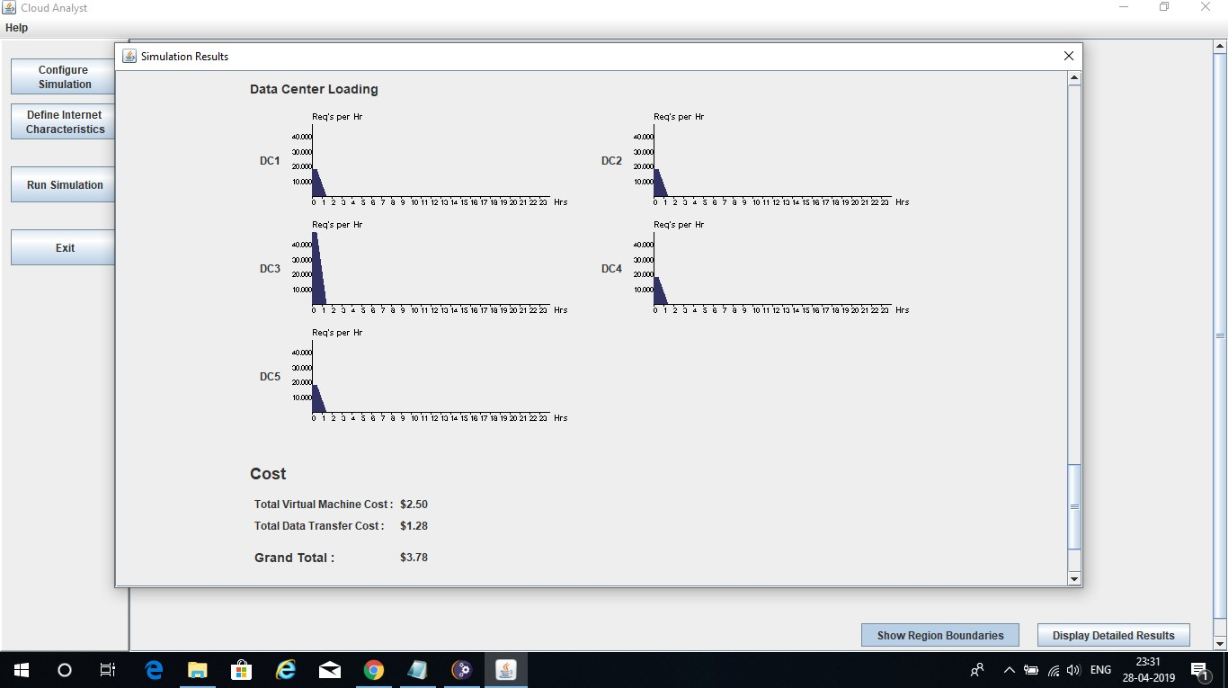

# Simulation #8

* **Broker Policy : Optimize Response Time**

# Load Balancing Policy : Equally Spread Current Execution Load

* **Having 20 User Bases**

# Having 5 Data Centers In 5 different Regions

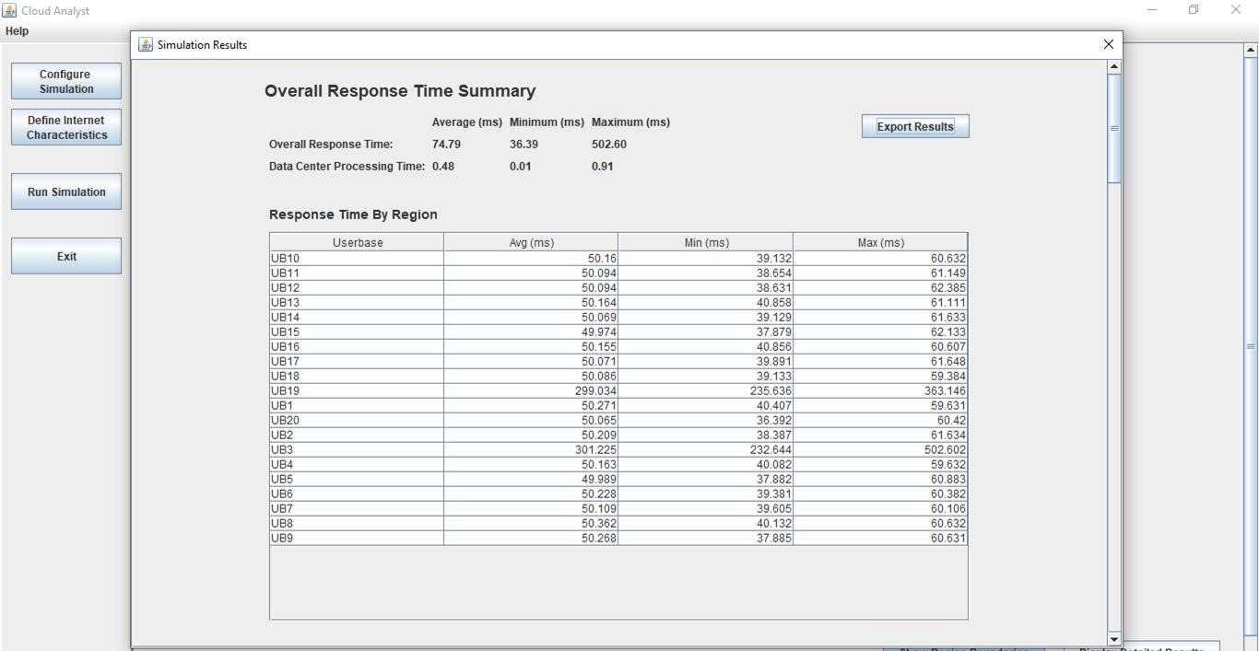

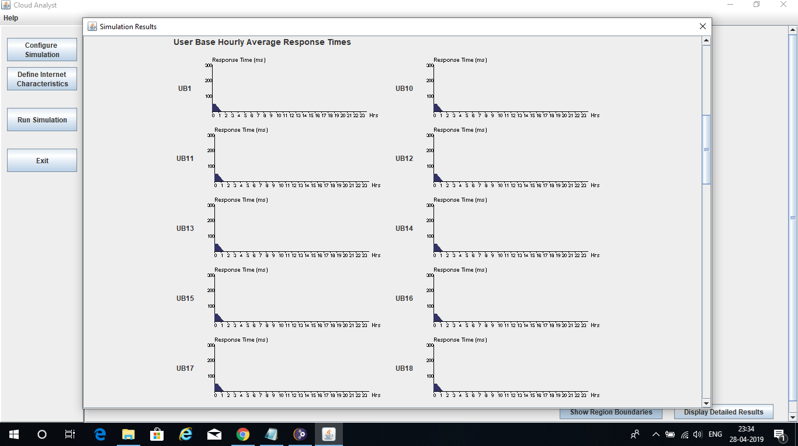

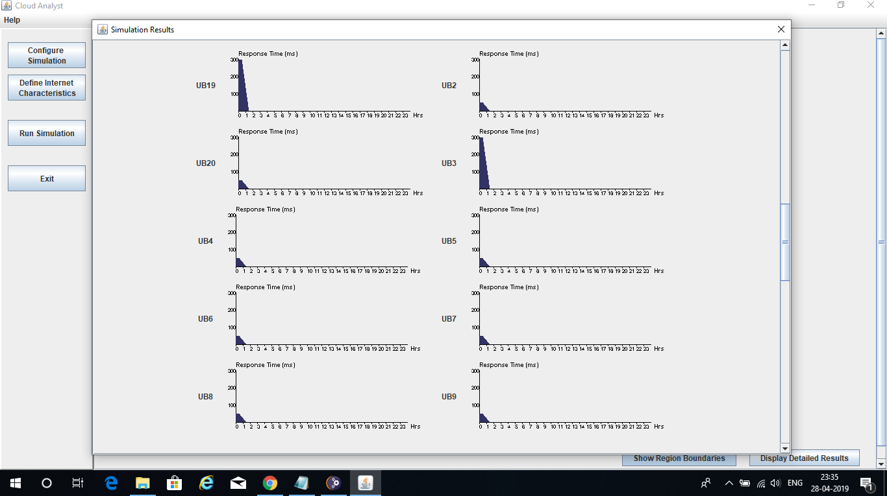

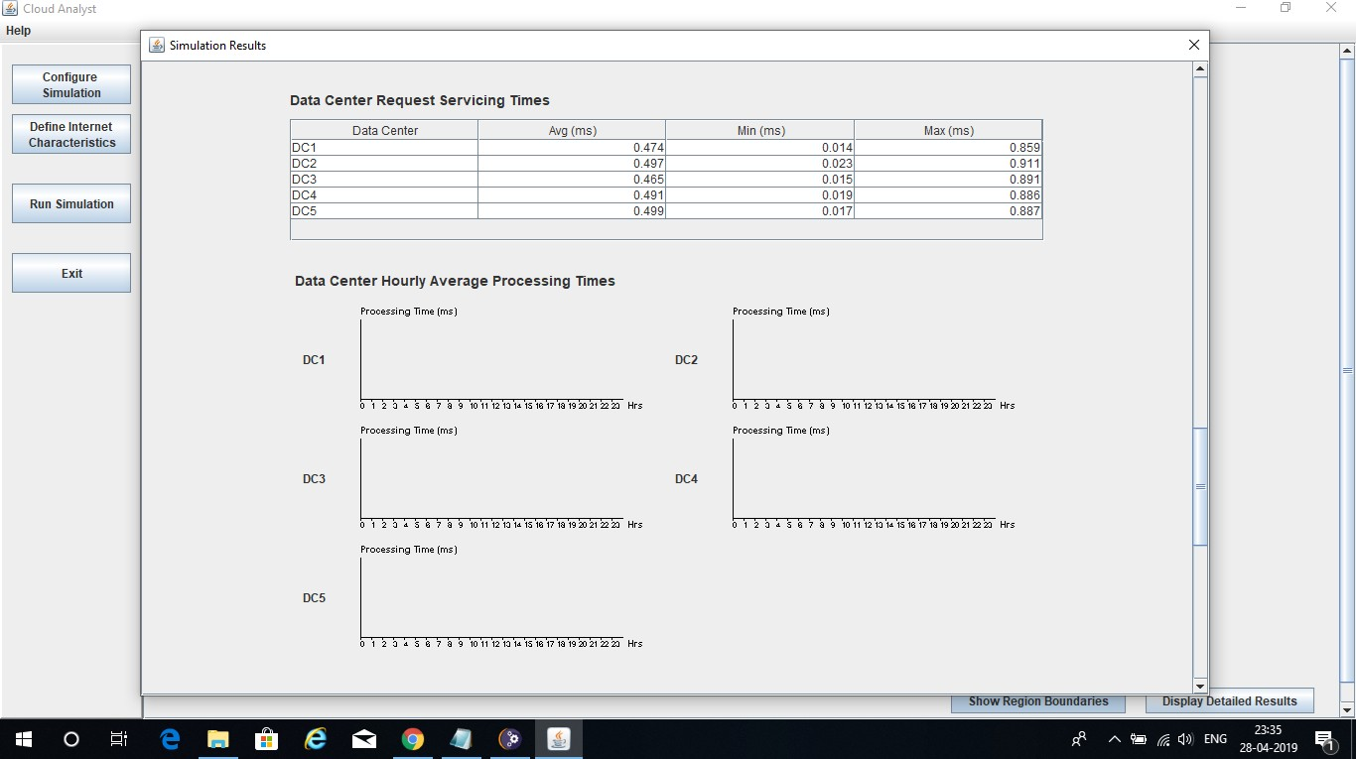

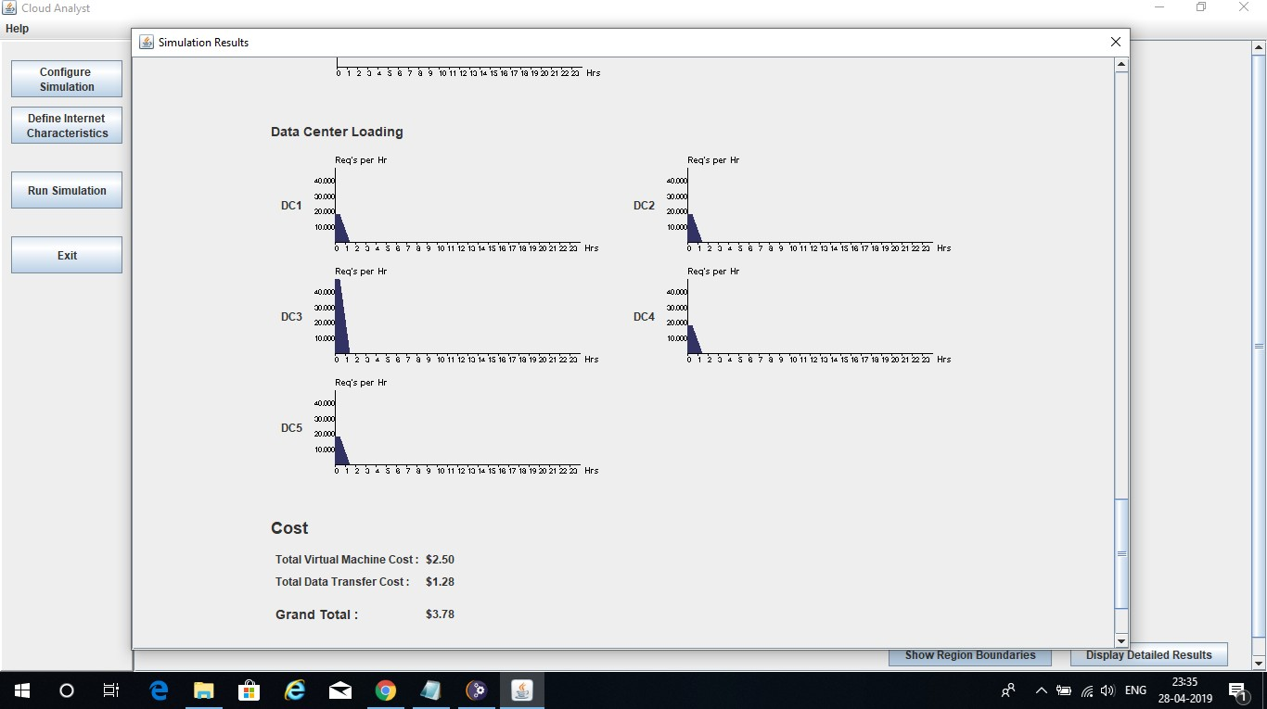

**Simulation #9**

# Broker Policy : Re-configure Dynamically with Load

* **Load Balancing Policy : Equally Spread Current Execution Load**

# Having 20 User Bases

* 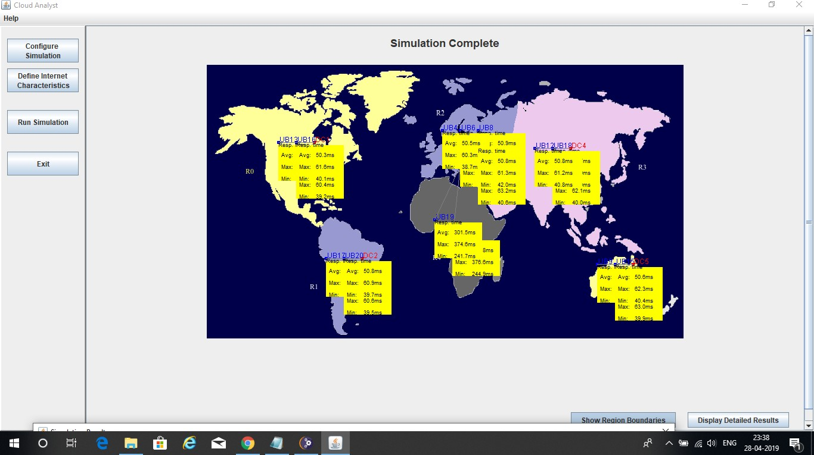**Having 5 Data Centers In 5 different Regions**

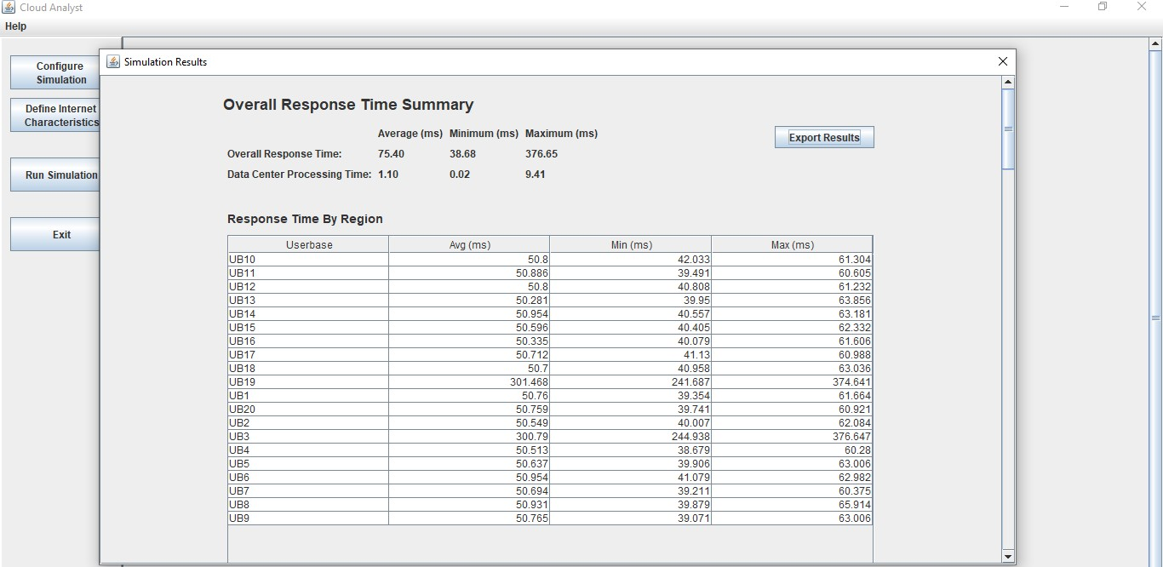

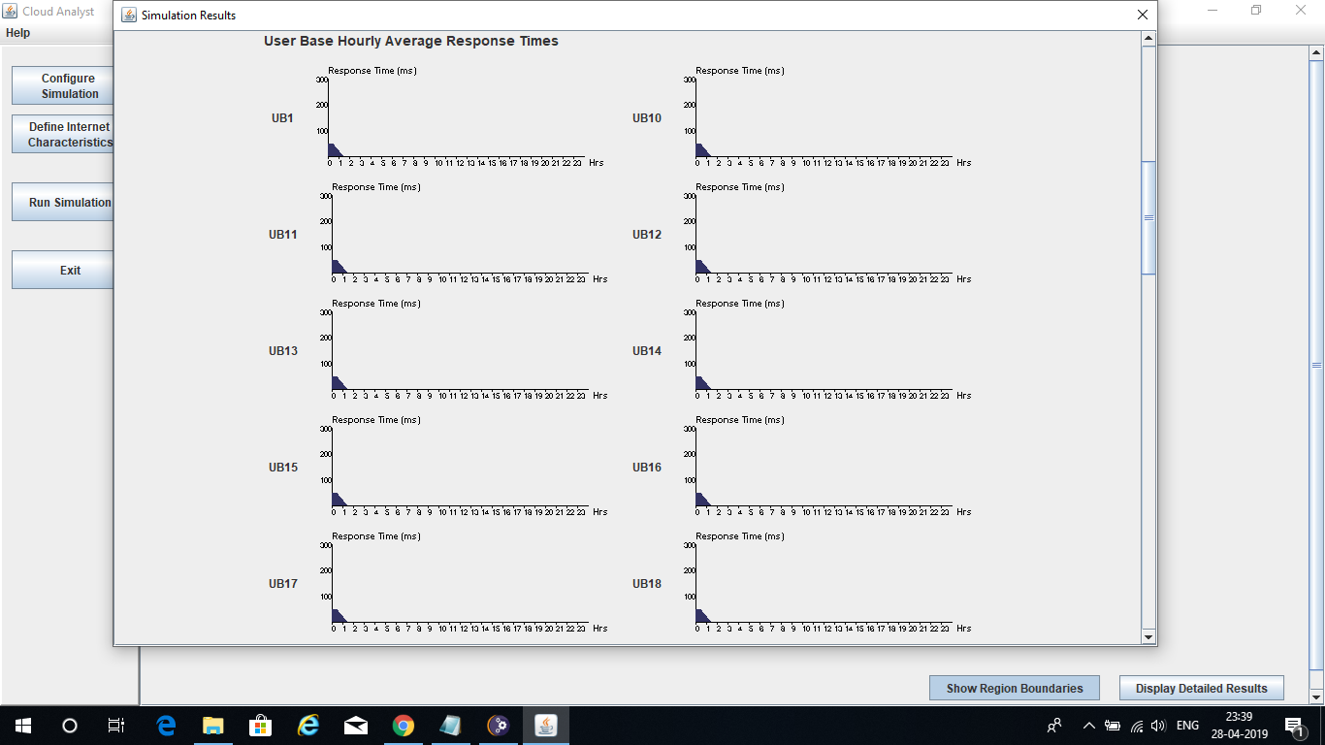

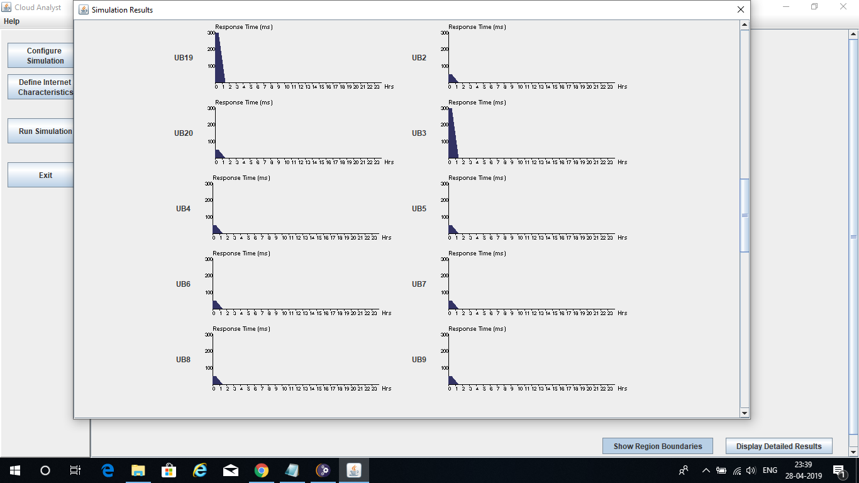

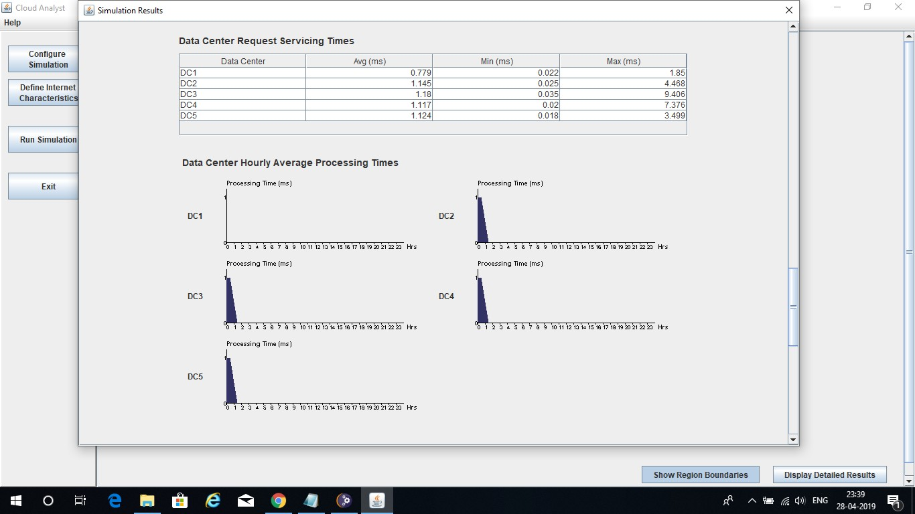

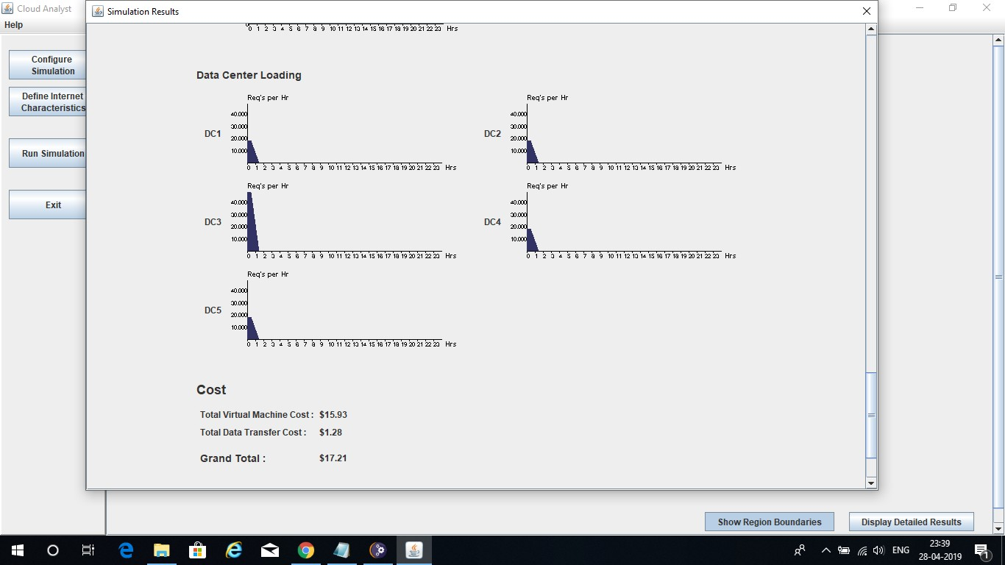

**Chapter 7 CONCLUSION**

In this report we conclude that the combinations of three Round Robin, Throttled and Equally Spread Current Execution VM load balancing algorithms and three different datacenters broker policies in cloud computing environments. We proposed a simulation scenario for evaluating the performance of these load balancing approaches. By these combinations, we generate the nine different possible load balancing approaches. We Analysed the performance of these approaches by simulating on Cloud Analyst simulator. The simulation results shows that throttled algorithm have a better performance than other load balancing algorithms, because it uses a threshold and available VM list for preventing serve the workload by overloaded VMs. In addition we analysed and offered the best combinations of each VM load balancer with datacenter broker policy.

**Chapter 8 REFERENCES**

[**www.google.co.in**](http://www.google.co.in/)[**www.wikipedia.com**](http://www.wikipedia.com/)[**www.cloudforge.com**](http://www.cloudforge.com/)[**www.youtube.com**](http://www.youtube.com/)